Sea of Love (George Khoury & John Phillip Baptiste, 1959)
Arrangement: Sea of Love by Phil Phillips (John Phillip Baptiste) (1959)

Intro: First verse melody
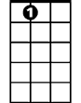





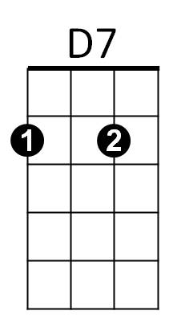
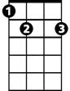

E7
D7
G7
G
F
C
BARITONE
G7
E7
G
F
C
C E7
Come with me, my love
F D7
To the sea, the sea of love
C F G7 C F C G
I want to tell you, how much I love you.

C E7
Do you remember when we met
F D7
That's the day I knew you were my pet
C F G7 C F C F
I want to tell you, how much I love you.

G F G F E7 G7
Come with me . . . to the sea, of - love.

Repeat from Verse Two

C E7
Do you remember when we met
F D7
That's the day I knew you were my pet
C F G7 C F C
I want to tell you, how much I love you.

