Sea of Love (George Khoury & John Phillip Baptiste, 1959)
Arrangement: Sea of Love by the Honeydrippers (1984)

C E7
Do you remember when we met
F D7
That's the day I knew you were my pet
C F G7 C F C
I want to te ll you, how much I love you.

C E7
Come with me my love
F D7
To the sea, the sea of love
C F G7 C F C (C/ G/ F/)
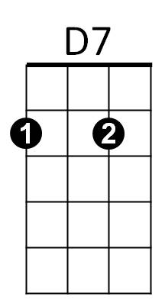



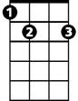

I wanna tell you, just how much I love you.
G7
G
C
E7
F

G F G F E7 G7
Come with me . . . to the sea, of - love .

Repeat Verse One

Instrumental Second Verse

G F G F E7 G7
Come with me . . . to the sea, of - love.

C E7
Do you remember my love
F D7
To the sea, the sea of love
C F G7 C F C
I wanna tell you, just how much I love you.
C F G7 C F C
I wanna tell you, oh, how much I love you.

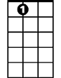

BARITONE
G
G7
E7
F
D7
C

