Secret Agent Man (Steve Barri / P F Sloan) Key Am


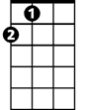
A Am\F 4x
Dm
Am
A
Am Dm Am
There's a man who leads a life of danger
E7
To everyone he meets he stays a stranger

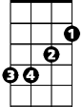
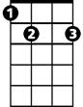
Am Dm
F
Em
E7
With every move he makes, another chance he takes
Am Dm Am
Odds are he won't live to see tomorrow

Chorus:
Em Am Em Am
Secret agent man, secret agent man
F E7 Am Am\F A
They've given you a number and taken away your name



Am Dm Am
Dm
Am
A
BARITONE
Beware of pretty faces that you find
E7
A pretty face can hide an evil mind
Am Dm
Ah, be careful what you say, Or you'll give yourself away

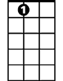
Am Dm Am
F
Em
E7
Odds are he won't live to see tomorrow

(Chorus)

Am Dm Am
Swingin' on the Riviera one day
E7
And then layin' in the Bombay alley next day
Am Dm
Oh no, you let the wrong word slip, while kissing persuasive lips
Am Dm Am
Odds are you won't live to see tomorrow

(Chorus)

Am\F A 3x

TACET
Secret agent man
Secret Agent Man (Steve Barri / P F Sloan) Key Dm
Dm\F 4x
Gm
Dm
D
Dm Gm Dm
There's a man who leads a life of danger
A7
To everyone he meets he stays a stranger
Dm Gm
A7
Bb
Am
With every move he makes, another chance he takes
Dm Gm Dm
Odds are he won't live to see tomorrow

Chorus:
Am Dm Am Dm
Secret agent man, secret agent man
Bb A7 Dm Dm\F D
They've given you a number and taken away your name
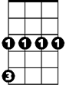

Gm
D
Dm
BARITONE
Dm Gm Dm
Beware of pretty faces that you find
A7
A pretty face can hide an evil mind
Dm Gm
Ah, be careful what you say, Or you'll give yourself away
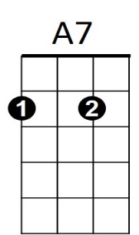
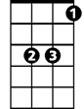
Dm Gm Dm
Am
Bb
Odds are he won't live to see tomorrow

(Chorus)

Dm Gm Dm
Swingin' on the Riviera one day
A7
And then layin' in the Bombay alley next day
Dm Gm
Oh no, you let the wrong word slip, while kissing persuasive lips
Dm Gm Dm
Odds are you won't live to see tomorrow

(Chorus)

Dm\F D 3x

TACET
Secret agent man
Secret Agent Man (Steve Barri / P F Sloan) Key Em
Em\C 4x
Em
Am
BARITONE
Em Am Em
There's a man who leads a life of danger
B7
To everyone he meets he stays a stranger

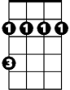
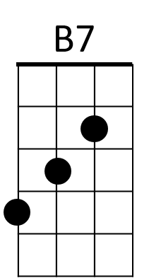
Em Am
C
Bm
With every move he makes, another chance he takes
Em Am Em
Odds are he won't live to see tomorrow

Chorus:
Bm Em Bm Em
Secret agent man, secret agent man
C B7 Em Em\C E
They've given you a number and taken away your name

Em Am Em
Am
Em
E
Beware of pretty faces that you find
B7
A pretty face can hide an evil mind
Em Am
Ah, be careful what you say, Or you'll give yourself away
Em Am Em
B7
Bm
C
Odds are he won't live to see tomorrow

(Chorus)

Em Am Em
Swingin' on the Riviera one day
B7
And then layin' in the Bombay alley next day
Em Am
Oh no, you let the wrong word slip, while kissing persuasive lips
Em Am Em
Odds are you won't live to see tomorrow

(Chorus)

Em\C E 3x

TACET
Secret agent man

