See You in September (Sherman Edwards and Sid Wayne, 1959) (Am)
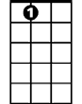
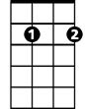
Intro: Em7 A7
A7
Em7
I’ll be a-lone each and ev-‘ry night,
Em7 A7
While you’re a-way, don’t for-get to write
Am7 D7 Am7 D7
B ye-bye, so long fare-well, bye-bye, so long.

Am7 D7 Bm E7
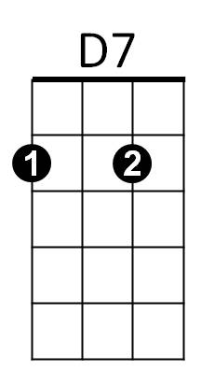
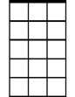
See you in Sep-tember.
Am7
Am7 D7 Bm E7
See you when the summer’s through.
Am7 D7 Bm E7
Here we are ----- saying good-bye at the sta---tion
(Bye baby, good-bye --------------------- --bye baby good-bye)
Am7 A7 Am7 D7
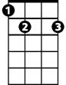
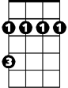
Summer va-ca----tion is taking you a-way.
E7
Bm
(Bye baby, good-bye------- bye baby good-bye)

Chorus
Am7 D7 Bm E7
Have a good time, but re-member.
Am7 D7 Bm E7
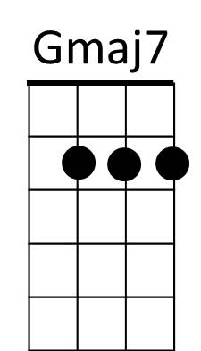
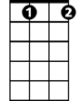
There is dan-ger in the summer moon a-bove.
Bbdim
Am7 Bbdim Gmaj7 E7 Am7 D7 Em7
Will I see you in Sep-tember? or lose you to a summer love
Em7 A7
Counting the days till I’ll be with you—
Em7 A7
Count-ing the hours and the min-utes, too
Am7 D7 Am7 D7
Bye baby, good-bye bye baby good-bye.
Am7 D7 Bm E7
Bye baby, good-bye . . bye baby good-bye.
(Bye-bye-- so long fare-well, bye-bye- so long)

(Chorus)

Am7 D7 Gmaj7 E7 (Repeat to fade)
See you in Sep - tem - - ber.
(Bye-bye-- so long fare-well, bye-bye- so long)
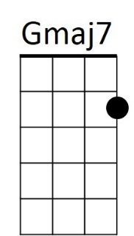
BARITONE
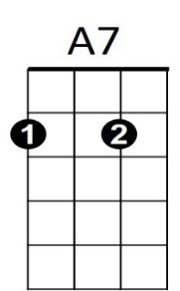
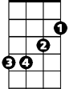
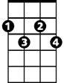

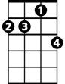
Bm
E7
Bbdim
D7
Am7
Em7

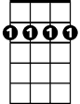
See You in September (Sherman Edwards and Sid Wayne, 1959) (Em)
E7
Bm7
Intro: Bm7 E7
I’ll be a-lone each and ev-‘ry night,
Bm7 E7
While you’re a-way, don’t for-get to write
Em7 A7 Em7 A7
B ye-bye, so long fare-well, bye-bye, so long.
A7
Em7
Em7 A7 F#m B7
See you in Sep-tember.
Em7 A7 F#m B7
See you when the summer’s through.
Em7 A7 F#m B7
Here we are ----- saying good-bye at the sta---tion
(Bye baby, good-bye --------------------- --bye baby good-bye)
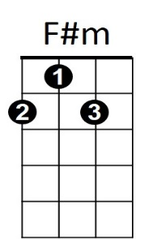
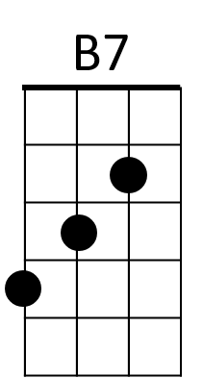
Em7 E7 Em7 A7
Summer va-ca----tion is taking you a-way.
(Bye baby, good-bye------- bye baby good-bye)

Chorus
Em7 A7 F#m B7
Have a good time, but re-member.
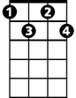
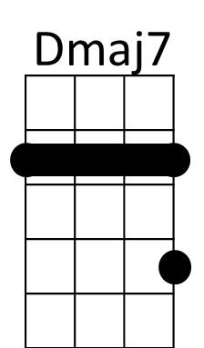
Em7 A7 F#m B7
Fdim
There is dan-ger in the summer moon a-bove.
Em7 Fdim Dmaj7 B7 Em7 A7 Bm7
Will I see you in Sep-tember? or lose you to a summer love
Bm7 E7
Counting the days till I’ll be with you—
Bm7 E7
Count-ing the hours and the min-utes, too
Em7 A7 Em7 A7
Bye baby, good-bye bye baby good-bye.
Em7 A7 F#m B7
Bye baby, good-bye . . . bye baby good-bye.
(Bye-bye-- so long fare-well, bye-bye- so long)

(Chorus)

Em7 A7 Dmaj7 B7 (Repeat to fade)
See you in Sep - tem - - ber.
(Bye-bye-- so long fare-well, bye-bye- so long)
BARITONE
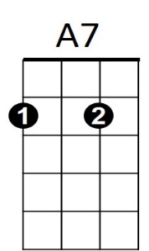
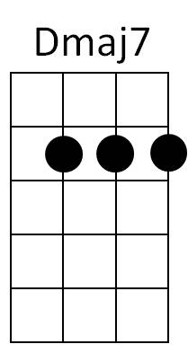
Bm7
E7
Em7
F#m
B7
Fdim

