Semper Paratus (Always Ready) (Capt. Francis Van Boskerck, USCG)
The United States Coast Guard theme song




F
C7
A7
Dm
F
From Aztec Shore to Arctic Zone,
C7 F
To Europe and Far East
C7 F A7 Dm
The Flag is carried by our ships,



G7 C
G7
Bb
C
In times of war and peace
F
And never have we struck it yet,
C7 F
In spite of foemen's might,
C7 F A7 Dm
Who cheered our crews and cheered a - gain,
F C7 F C7
For showing how to fight.

Chorus:

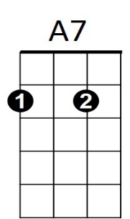

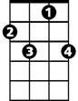
F
BARITONE
Dm
C7
F
We're always ready for the call,
Bb F
We place our trust in Thee.
C7 F A7 Dm
Through surf and storm and howl-ing gale,
G7 C C7
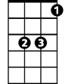
High shall our purpose be
G7
Bb
C
F
"Semper Paratus" is our guide,
Bb F
Our fame, our glory, too.
C7 F A7 Dm
To fight to save or fight and die!
F C7 F
Aye! Coast Guard, we are for you.

(Repeat Chorus)

