
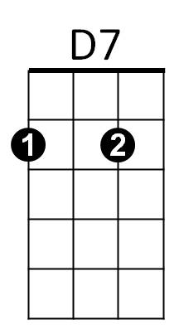
She's Always a Woman to Me (Billy Joel)
D7

G D7 G D7 G
She can kill with a smile, she can wound with her eyes.
C Em C
She can ruin your faith with her cas-u-al lies.
D7 G D7 Bm
And she only reveals what she wants you to see.

Em Am C D7 G
G
She hides like a child, but she's always a woman to me.

D7 G D7 G
She can lead you to love, she can take you or leave you.
C Em C

She can ask for the truth, but she'll ne-ver believe.
C
D7 G D7 B
And she'll take what you give her as long it's free.
Em Am C D7 G
She steals like a thief, but she's always a woman to me.

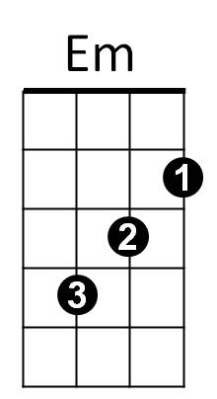
CHORUS:

Em A7 D Bm
Ohhh... she takes care of herself.
G C Am D7 G
She can wait if she wants, she's ahead of her time.
Gm C7 F Dm
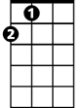
Ohhh... and she never gives out,
A
Eb A A7 D
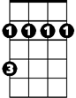
And she never gives in, she just changes her mind.
Bm

D7 G D7 G
And she'll promise you more than the garden of Eden.
C Em C
Then she'll carelessly cut you and laugh while you're bleeding.
D7 G D7 Bm
But she brings out the best and the worst you can be.
Em Am C D7 G
Blame it all on yourself, 'cause she's always a woman to me.
D7 G D7 Bm
Mmmmmmmmmmmmmmmmmmmmmmmmmmm
Em Am C D7 G
Mmmmmmmmmmmmmmmmmmmmmmmmmmm
G

(CHORUS)

D7 G D7 G
She's frequently kind and she's suddenly cruel.

C Em C
Em
She can do as she pleases, she's nobody's fool.
D7 G D7 Bm
But she can't be convicted, she's earned her degree.
Em Am

And the most she will do is throw shadows at you,
C
C D7 G
But she's always a woman to me.
D7 G D7 Bm
Mmmmmmmmmmmmmmmmmmmmmmmmmmm
Em Am C D7 G
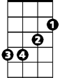
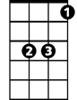

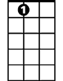

Mmmmmmmmmmmmmmmmmmmmmmmmmmm
Bm
Eb
D
D
A7
Am
Am
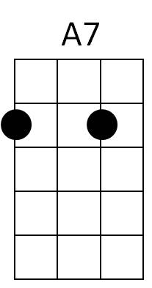
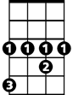

A
Eb
Dm
Dm

