She’s Not There (Rod Argent)

Intro: / Am - D - / x4
Am
D

Am D Am D Am F Am D
Well no one told me about her, the way she lied
Am D Am D Am F A
Well no one told me about her, how many people cried
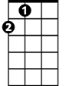
Dm
F
A
Chorus:
D Dm Am
But it's too late to say you're sorry
Em Am
How would I know, why should I care
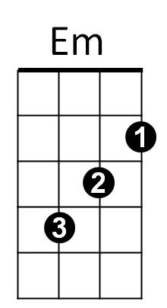
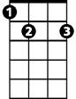 D Dm C
E7
Please don't bother tryin' to find her
E7
She's not there
Am D
Well let me tell you 'bout the way she looked
Am F Am D
The way she'd acted and the color of her hair
Am F
BARITONE
Her voice was soft and cool
 Am D
D
Am
F
Her eyes were clear and bright
A
But she's not there

Am - D - / x4

A
Dm
Em
Am D Am D Am F Am D
Well no one told me about her, what could I do
Am D Am D Am F A
Well no one told me about her, though they all knew
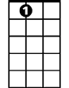
E7
Repeat Chorus

