Shine on Harvest Moon (Gerald Casale / Mark Allen Mothersbaugh)
Key Am
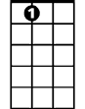
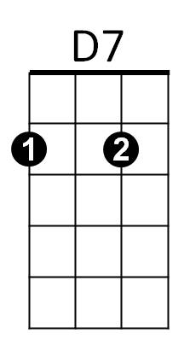
A 7 D7
A7
Oh shine on shine on harvest moon up in the sky
G7 C F C
I ain't had no lovin' since January February June or July
A7 D7


Snow time ain't no time to sit outdoors and spoon
G7
C
G7 C F C
So shine on shine on harv est moon for me and my gal

Am E7 Am
The night wa s mighty dark so you could hardly see

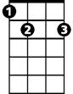


C E7
Am
E7
G
F
Cause the moon refused to shine
Am E7 Am
Couple sittin' underneath the willow tree
D7 G
For love they pine
BARITONE

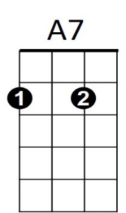
G G7
C
G7
D7
Little maid was mighty afraid of darkness
C
So she said, “I think I'll go!”
D7


Boy began to sigh, looked up at the sky
F
Am
G G7
And told the moon his little tale of woe

A7 D7
Oh shine on shine on harvest moon up in the sky
G7 C F C
G
E7
I ain't had no lovin' since January February June or July
A7 D7
Snow time ain't no time to sit outdoors and spoon
G7 C F C
So shine on shine on harvest moon for me and my gal

Shine on Harvest Moon (Gerald Casale / Mark Allen Mothersbaugh)
Key Em
E7 A7
E7
A7
BARITONE
Oh shine on shine on harvest moon up in the sky
D7 G C G
I ain't had no lovin' since January February June or July
E7 A7
Snow time ain't no time to sit outdoors and spoon
G
D7 G C G
So shine on shine on harvest moon for me and my gal

Em B7 Em
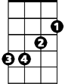
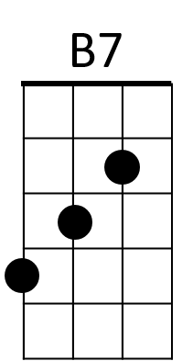

The night was mighty dark so you could hardly see
Em
D
G B7
C
Cause the moon refused to shine
Em B7 Em
Couple sittin' underneath the willow tree
A7 D
For love they pine
D D7
G
D7
E7
Little maid was mighty afraid of darkness
G
So she said, “I think I'll go!”
A7
Boy began to sigh, looked up at the sky
C
Em
D D7
And told the moon his little tale of woe

E7 A7
Oh shine on shine on harvest moon up in the sky
D
B7
D7 G C G
I ain't had no lovin' since January February June or July
E7 A7
Snow time ain't no time to sit outdoors and spoon
D7 G C G
So shine on shine on harvest moon for me and my gal

