Since I Fell For You (Buddy Johnson)

Intro:
Cmaj7 F Cmaj7 F
When you just give love, and never get love,
Cmaj7 Am Dm G7
You'd better let love depart----
F Fm Em A7
I know it's so, and yet I know
D7 G G7
I can't get you out of my heart---

Cmaj7 Am F
You.......... .
G7 Cmaj7 Am F
Made me leave my happy home-.
G7 F Fm
You took my love, and now you're gone,......
Am G Cmaj7 Am F G
Since I fell....for you .........
-
Cmaj7 Am F
Love............ ...
G7 Cmaj7 Am F.
Brings such misery and pain.........
G7 F Fm
I guess I'll never be the same,....
Am G Cmaj7 F C C7
Since I fell....for you .........

F Fm
Well it's too bad, and it's too sad,
Cmaj7 F C C7
BARITONE
But I'm still in love with you
F Fm
First you love me, then you snub me.
Cmaj7 Am
But what can I do
F G
'Cause I'm still in love with you.
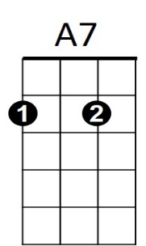

Cmaj7 Am F
Well I.....................
G Cmaj7 Am F
Guess I'll never see the light......
G7 F Fm
I get the blues most ev-ery night,.....
Am G Cmaj7 Am F
Since I fell....for you .........
G C F Cmaj7


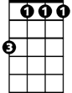



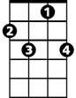


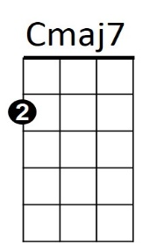


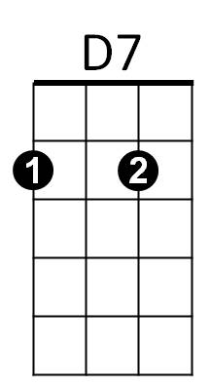
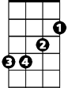
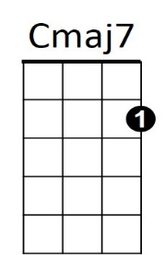
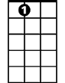
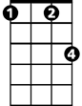
Since I fell.....for you ...
G
C
Fm
Em
D7
G7
C7
Dm
Am
F
C7
C
G
Em
G7
A7
Fm
Am
Dm
F

