Singin’ in the Rain (Arthur Freed / Nacio Herb Brown) Key C

Intro: C Am C Am (2X)



C Am C Am
C
Am
I'm singing in the rain just singin' in the rain
C Am Dm G7
What a glorious feeling, I'm happy again
Dm G7 Dm G7


I'm laughing at clouds so dark up above
Dm
G7
Dm G7 C
The sun's in my heart and I'm ready for love

C Am C Am
Let the stormy clouds chase everyone from the place
C Am Dm G7
Come on with the rain, I've a smile on my face
Dm G7 Dm G7
I walk down the lane with a happy refrain
Dm G7 C

Just singin', singin' in the rain
BARITONE
C
Am

C Am C Am (2X)

C Am C Am
Dancing in the rain,


C Am Dm (stop) G7
G7
Dm
I'm happy again
Dm G7 Dm G7

Dm G7 C
I'm singin' and dancing in the rain

(Second verse)

Dm G7 C
I'm dancing and singin' in the rain

Singin’ in the Rain (Arthur Freed / Nacio Herb Brown) Key G


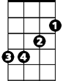
Intro: G Em G Em (2X)
G
Em

G Em G Em
I'm singing in the rain just singin' in the rain
G Em Am D7
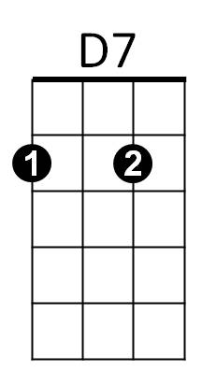
What a glorious feeling, I'm happy again
Am
Am D7 Am D7
I'm laughing at clouds so dark up above
Am D7 G
The sun's in my heart and I'm ready for love

G Em G Em
Let the stormy clouds chase everyone from the place
G Em Am D7
Come on with the rain, I've a smile on my face
Am D7 Am D7
I walk down the lane with a happy refrain
Am D7 G
Just singin', singin' in the rain
BARITONE
D7
Em
G
Am
G Em G Em (2X)

G Em G Em
Dancing in the rain,
G Em Am (stop) D7
I'm happy again
Am D7 Am D7

Am D7 G
I'm singin' and dancing in the rain

(Second verse)

Am D7 G
I'm dancing and singin' in the rain

