Sit Down, You're Rockin' the Boat (Frank Loesser)

Dm Cm6
I dreamed last night I got on the boat to heaven
Dm Cm6
And by some chance I had brought my dice along
Am Gm7 Am Gm7
And there I stood and I hollered "Someone fade me"
Am Dm Gm7 C7
But the passengers, they knew right from wrong
F F7 Gm7 Bbm6
For the people all said sit down
F G7 C7
Sit down, you're rockin' the boat
F F7 Gm7 Bbm6
The people all said sit down
F C7 F F7
Sit down you're rockin' the boat
Gm7
And the devil will drag you under
Bbm6
By the sharp lapel of your checkered coat
F F7 Gm7 Bbm6
Sit down, sit down, sit down, sit down
F C7 F A7
Sit down you're rockin' the boat

Dm
Dm Cm6
I sailed away on that little boat to heaven
Dm Cm6
And by some chance found a bottle in my fist

Am Gm7 Am Gm7
F
And there I stood nicely passin' out the whisky
Am Dm Gm7 C7
BARITONE
But the passengers were bound to resist
F F7 Gm7 Bbm6
For the people all said beware
F G7 C7

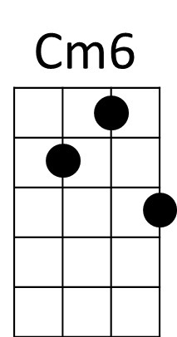
You're on a heavenly trip
Am
Dm
F F7 Gm7 Bbm6
The people all said beware
F C7 F F7
Beware, you'll scuttle the ship
Gm7
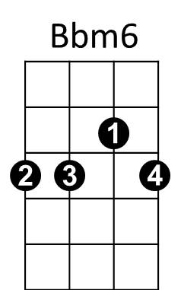

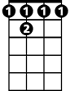

And the devil will drag you under
F
F7
G7
Bbm6
By the fancy tie 'round your wicked throat
F F7 Gm7 Bbm6
Sit down, sit down, sit down, sit down
F C7 F A7
Sit down you're rockin' the boat
Dm Cm6
And as I laughed at those passengers to heaven
Dm Cm6
A great big wave came and washed me over board
Am Gm7 Am Gm7
And as I sank and I hollered "someone save me"
Am Dm Gm7 C7
That's the moment I woke up, thank the Lord
F F7 Gm7 Bbm6
And I said to myself sit down
F G7 C7
Sit down, you're rockin' the boat
F F7 Gm7 Bbm6
I said to myself sit down
F C7 F F7
Sit down you're rockin' the boat
Gm7
And the devil will drag you under
Bbm6
With a soul so heavy you'd never float
(3x) F F7 Gm7 Bbm6
Sit down, sit down, sit down, sit down
F C7 F
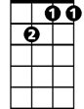

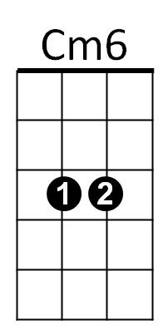
Sit down you're rockin' the boat
C7
Gm7
Am

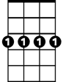
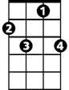
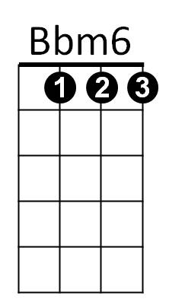
G7
Gm7
C7
F7

