Sleigh Ride (Anderson / Parish)
C Am Dm (x3) F C Dm G

G C Am
Just hear those sleigh bells jing-a-ling
Dm G C
Ring ting ting-a-ling too
G C Am

Come on its lovely weather
Am
Dm G C
For a sleigh ride together with you
G C Am
Outside the snow is falling
Dm G C
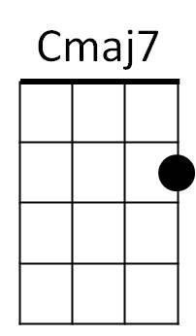


And friends are calling yoo-hoo
Dm
G
G C Am
Come on its lovely weather
Dm G C
For a sleigh ride together with you

F#m B
Giddy-up giddy-up giddy-up let's go
E7
Let's look at the show
F#m B E7
We're riding in a wonderland of snow
Em A
Giddy-up giddy-up giddy-up it's grand
D
Just holding your hand
Dm
We're riding along with a song
G
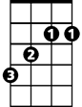
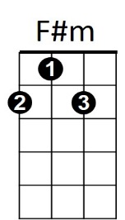
Of a wintery fairyland
B

G C Am
Our cheeks are nice and rosy
Dm G C
And comfy coz y are we
G C Am
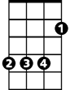

We snuggle close together
E
F

Dm G C
Like two birds of a feather would be
G C Am
Let's take that road before us
Dm G C
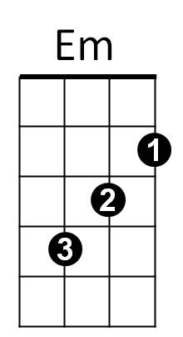
And sing a chorus or two
G C Am
Come on its lovely weather
Dm G C
For a sleigh ride together with you

G
There's a birthday party at the home of Farmer Grey
Em Am
It'll be the perfect ending of a perfect day

C F
We'll be singing the songs we love to sing
G Am
Without a single stop
E7 F#m E
At the fireplace where we'll watch the chestnuts pop
Dm G
Pop! Pop! Pop!
G
There's a happy feeling nothing in this world can buy
Em
When they pass around the coffee
Am
and the pumpkin pie
C F G Am
It'll nearly be like a picture print by Currier & lives
G
These wonderful things are the things
Dm G
We remember all through our lives
Dm
These wonderful things are the things
G
We remember all through our lives

Repeat first three verses

Outro (repeat 3x)
G C Am
Come on its lovely weather
Dm G C Am Dm G C
For a sleigh ride together with you
BARITONE

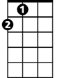


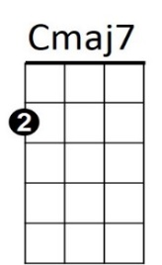
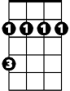
B
F
Em
E
Am
C
Dm
G
F#m

