Smoke Gets in Your Eyes

C Am Dm G C Am F
They asked me how I knew, my true love was true, oh, oh,
Dm Em A7 Dm G C Am Dm G
I of course replied, something here inside cannot be denied.
C Am Dm G C Am F
They said, someday you'll find all who love are blind, oh, oh,
Dm Em A7 Dm G C
When your heart's on fire, you must realize smoke gets in your eyes.

C
G
Dm
Eb C Eb

Ab
So I chaffed them and I gaily laughed,
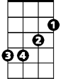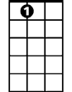 Eb D Eb
Em
F
A7
To think they could doubt my love.
Ab Fm
Yet today my love has flown away,
C Am Dm G
I am without my love.

C Am Dm G C Am F
Now laughing friends deride tears I cannot hide, oh, oh
Dm Em A7 Dm
So I smile and say, when a lovely flame dies,
G C Dm
Smoke gets in your eyes, your eyes,
Dm F C
Smoke gets in your eyes.
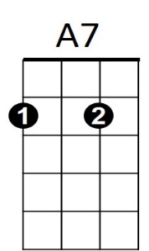
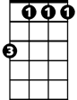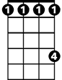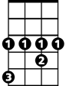
BARITONE
Fm
Ab
Eb
EmAm
F
G
Dm
Am
C
Smoke Gets in Your Eyes

D Bm Em A D Bm G
They asked me how I knew, my true love was true, oh, oh,
Em F#m B7 Em A D -Bm-Em-A
I of course replied, something here inside cannot be denied.
D Bm Em A D Bm G
They said, someday you'll find all who love are blind, oh, oh,
Em F#m B7 Em A D
when your heart's on fire, you must realize smoke gets in your eyes.

- G - D - F

Bb
So I chaffed them and I gaily laughed,
F E F
to think they could doubt my love.
Bb Gm
Yet today my love has flown away,
D Bm Em - A
I am without my love.

D Bm Em A D Bm G
Now laughing friends deride tears I cannot hide, oh, oh
Em F#m B7 Em
so I smile and say, when a lovely flame dies,
A D Em
smoke gets in your eyes, your eyes,
D Em G Em G D
smoke gets in your eyes, smoke gets in your eyes.

