Smooth (Robert Thomas / Itaal Shur)
Intro: Am F E E7

Am F E
Man, it's a hot one
E7 Am F E
Like seven inches from the midday sun
E7 Dm7
Well, I hear you whisper and the words melt everyone
E7
But you stay so cool
Am F E E7 Am F E
My muñequita, my Spanish Harlem Mona Lisa
E7 Dm7
You' re my reason for reason
E7
The step in my groove

Chorus:

Am E E7
And if you say this life ain't good enough
Am F E E7
I would give my world to lift you up
Am F E E7 Dm7
I could change my life to better suit your mood
E7
Because you're so smooth
Am E E7
And it's just like the ocean under the moon
Am F E E7
Oh, it's the same as the emotion that I get from you
Am F E E7
You got the kind of lovin' that can be so smooth, yeah
F Dm7 E7
Give me your heart, make it real or else forget about it

Am F E E7 (4X)

Am F E
But I'll tell you one thing
E7 Am F E
If you would leave it'd be a crying shame
E7 Dm7
In every breath and every word
E7
I hear your name calling me out
BARITONE

Am F E
Out from the barrio
E7 Am F E
You hear my rhythm on your radio
E7 Dm7
You feel the turning of the world, so soft and slow
E7
It's turning you round and round

(Chorus)

Am E E7
Oh, and it's just like the ocean under the moon
Am F E E7
Oh, it's the same as the emotion that I get from you
Am F E E7
You got the kind of lovin' that can be so smooth, yeah
F Dm7 E7
Give me your heart, make it real or else forget about it

(Repeat to fade)

Am F E E7
Or else forget about it

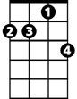


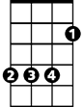
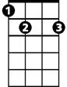
Dm7
Am
F
E
E7

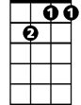
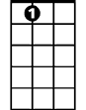

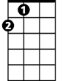

Dm7
E7
F
E
Am

Smooth (Robert Thomas / Itaal Shur)
Intro: Dm Bb A A7

Dm Bb A
Man, it's a hot one
A7 Dm Bb A
Like seven inches from the midday sun
A7 Gm7
Well, I hear you whisper and the words melt everyone
A7
But you stay so cool
Dm Bb A A7 Dm Bb A
My muñequita, my Spanish Harlem Mona Lisa
A7 Gm7
You're my reason for reason
A7
The step in my groove

Chorus:

Dm A A7
And if you say this life ain't good enough
Dm Bb A A7
I would give my world to lift you up
Dm Bb A A7 Gm7
I could change my life to better suit your mood
A7
Because you're so smooth
Dm A A7
And it's just like the ocean under the moon
Dm Bb A A7
Oh, it's the same as the emotion that I get from you
Dm Bb A A7
You got the kind of lovin' that can be so smooth, yeah
Bb Gm7 A7
Give me your heart, make it real or else forget about it

Dm Bb A A7 (4X)

Dm Bb A
But I'll tell you one thing
A7 Dm Bb A
If you would leave it'd be a crying shame
A7 Gm7
In every breath and every word
A7
I hear your name calling me out


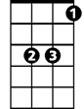

BARITONE
A
Bb
Dm

Dm Bb A
Out from the barrio
A7 Dm Bb A
You hear my rhythm on your radio
A7 Gm7
You feel the turning of the world, so soft and slow
A7
It's turning you round and round

(Chorus)

Dm A A7
Oh, and it's just like the ocean under the moon
Dm Bb A A7
Oh, it's the same as the emotion that I get from you
Dm Bb A A7
You got the kind of lovin' that can be so smooth, yeah
Bb Gm7 A7
Give me your heart, make it real or else forget about it

(Repeat to fade)

Dm Bb A A7
Or else forget about it

Gm7
Dm
Bb
A
A7

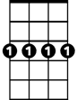
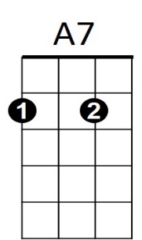
Gm7

