So Far Away (Carole King)

D D6
So far away -
D D6 G Em7
Doesn't anybody stay in one place anymore
A D G D
It would be so fine to see your face at my door
G F#m Em7
Doesn't help to know

A D D6
You're just time away –
D D6
Long ago I reached for you
G Em7
And there you stood
A D G D
Holding you again could only do me good
G F#m Em7 A D D6 D A
How I wish I could - but you're s o - far away

Bm D G D
One more song about moving along the highway
Em7 A D
Can't say much of anything that's n ew
F#m Em7
If I could only work this life out my way
A Bm Em7
I'd rather spend it bein' close to you

A D D6
But you're so far away -
D D6 G Em7
Doesn't anybody stay in one place anymore
A D G D
It would be so fine to see your face at my door
G F#m Em7
Doesn't help to know
A D D6 D
You're so far away –
D6 G Em7 A
Yeah you're so far away
BARITONE
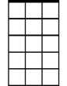
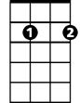
Em7
D6

G D Em7 G
Travelin' around sure gets me down and lonely
Em7 A D
Nothin' else to do but close my mind
F#m Em7
I sure hope the road don't come to own me
A Bm Em7 A7
There's so many dreams I've yet to find

A D D6
But you're so far away -
D D6 G Em7
Doesn't anybody stay in one place anymore
A D G D
It would be so fine to see your face at my door
G F#m Em7
Doesn't help to know
A D D6 D
You're so far away, yeah -
D6 G Em7 A
You're so far away yeah
D D6 D
You're so fa - ar away …

G Em7 D D6 FADE
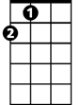
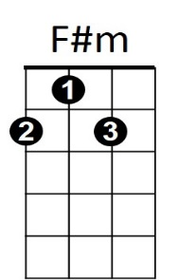
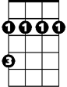

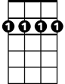

A
Bm
D
D6
G
Em7


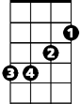
A
F#m
D
G
Bm

