Softly as I Leave You (Hal Shaper & A. de Vita)

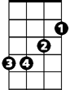
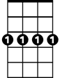
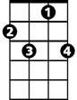





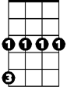
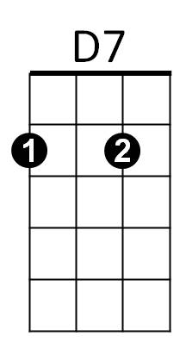
Intro: G Am D7 G Am
Em
Cm7
F7
Bb
G
Am
C
Dm
Cm

G Am D7
Softly, I will leave you,
G Am D7 G
Softly, for my heart would break,
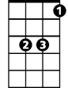
C G Am
Eb
If you should wake, and, see me go.
D7
So I leave you

G Cm7 F7 Bb
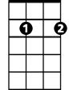
Softly, Long before you, miss me,
Em7
F7 Bb Eb
Long before, your arms, can make me stay,
Dm F7 G Am
For one more hour, or, one more day.

D7 G Cm
After all the years,
BARITONE


D7 Em Em7 C
C
D7
I can't bear the tears, to fall,
Am
G
Eb Cm7 D7 G Am D7
So softly, as I leave you there.

(Repeat from beginning)
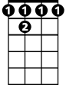
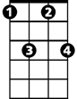
F7
Cm7
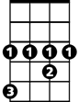
D7 G Am
Bb
Eb
As I leave you there.
D7 Cm7 G
As I leave you the - re.

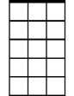
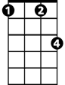

Em
Em7
Cm
Dm

