Some Enchanted Evening (Rodgers & Hammerstein, 1949)

Intro:
Gsus4 G
Once you have found her,
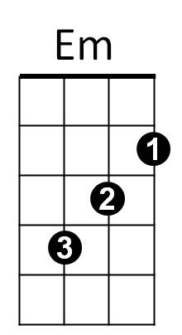

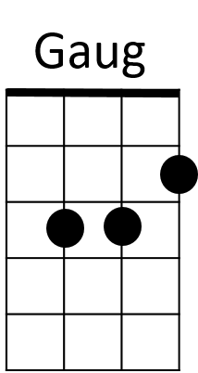


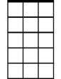
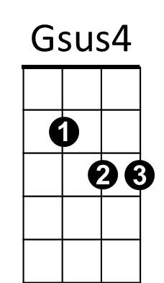

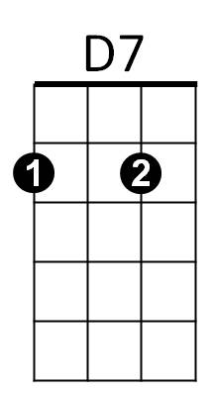
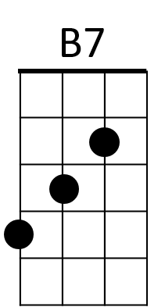

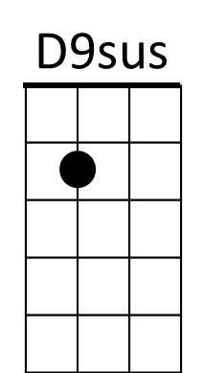
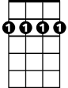
D7 G
D
C
Am
Am7
G
Dm
Bm7
Never let her go,
Gsus4 G
Once you have found her,
Am7 Am Am7 D9sus
Ne - ver let her - .

G
Some enchanted evening,
D7
You may see a stranger,
G Gaug
You may see a stranger
C Am7
Across a crowded room,
Bm7 Am7 D
And some how you know,
B7 Em Dm Am7
You know even then,
Bm7 Am7
That somewhere you'll see her
D7 G D7
A-gain and a-gain.

G
Some enchanted evening,
D7
Someone may be laughing,
G Gaug
You may hear her laughing
C Am7
Across a crowded room
Bm7 Am7 D
And night after night,
B7 Em Dm C
As strange as it seems,
Bm7 Am7
The sound of her laughter
D7 G
Will sing in your dreams.

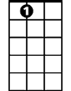
A7

Gsus4 G
Who can ex-plain it,
D7 G
Who can tell you why?
Gsus4 G
BARITONE
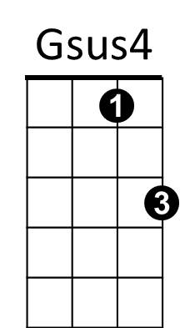
Fools give you reasons,
G
A7 Am7 D7
Wise men never try.

G
Some enchanted evening,
D7
When you find your true love,
G Gaug

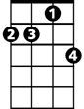
When you hear her call you
D7
Am7
C Am7
Across a crowded room,
Bm7 Am 7 D
Then fly to her side
B7 Em Dm C
And make her your own,
Bm7 Am7
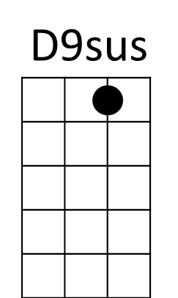
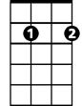
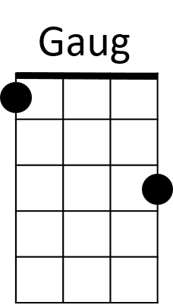

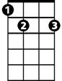
Or all through your life
Am
Bm7
C
D
Em
B7
D7 G
You ma y dream all a-lone.

Gsus4 G
Once you have found her,
D7 G
Never let her go,
Gsus4 G
Once you have found her,
Am7 Am Am7 D9sus G
Ne - ver let her go.

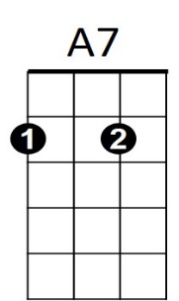

Dm

