Somewhere Over the Rainbow / What a Wonderful World (Iz version)
(E. Y. Harburg / Harold Arlen / Louis Armstrong)

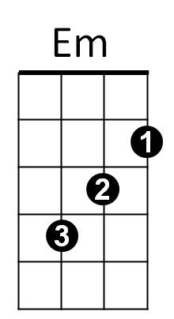

Intro: C Em Am F (2x)
C
Oooooo-oooooooo-ooooooooo

C Em F C
Somewhere over the rainbow, way up high


F C G Am F
F
Am
And the dreams that you dreamed of once in a lullaby
C Em F C
Somewhere over the rainbow, blue birds fly
F C
And the dreams that you dreamed of

G Am F
G
Dreams really do come true ooh oh

C
Someday I'll wish upon a star
G Am F
And wake up where the clouds are far behind me
C
Where trouble melts like lemon drops
G Am F
High above the chimney tops, that's where you'll find me


G
Em
C
Am
F
BARITONE
C Em F C
Somewhere over the rainbow, blue birds fly
F C G Am F
And the dreams that you dare to, why, oh why can't I?

C G Am C
Well, I see trees of green and red roses too
F C G Am
I watch them bloom for me and you
F G Am F
And I think to myself, what a wonderful world

C G Am C
Well, I see skies of blue and I see the clouds of white
F C G Am
And the brightness of day, I like the dark
F G Am F
And I think to myself, what a wonderful world

G Am
The colors of the rainbow, so pretty in the sky
G Am
Smiles on the faces of people passing by
F C F C
I see friends shaking hands saying, “How do you do?”
F C F G
They’re really saying, “I – I love you”

C G Am C
I see babies crying, I watch them grow
F C G Am
They’ll learn much more than we’ll know
F G Am F
And I think to myself, what a wonderful world, world

C
Someday I'll wish upon a star
G Am F
And wake up where the clouds are far behind me
C
Where trouble melts like lemon drops
G Am F
High above the chimney tops, that's where you'll find me

C Em F C
Oh, somewhere over the rainbow way up high
F C G Am F
And the dreams that you dare to, why, oh why can't I? I?
End with intro

