Somewhere (Leonard Bernstein and Stephen Sondheim, 1957)




G C F Dm
C
G
F
Dm
There’s a place for us
G C F
Somewhere a place for us
G G7 Em Am
Peace and quiet and open air



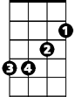

F Bb G
Gm
Bb
Am
Em
G7
Wait for us somewhere

G C F Dm
There's a time for us
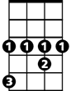
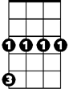
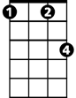
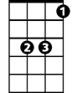
G C F
Ab
Cm
Fm
Eb
Someday a time for us
G G7 Em Am
Time together a time to spare
F Bb Gm Eb
Time to learn, time to care

BARITONE
G7
F
Ab Fm
Dm
C
G
Someday, somewhere
Cm Dm Ab
We'll find a new way of living
Fm Eb
Eb
We'll find a way of forgiving
Gm
Bb
Am
Em
D
Somewhere

G C F Dm
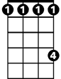
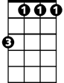
There’s a place for us
Ab
Cm
Fm
G C F
A time and a place for us
G G7 Em Am
Hold my hand and we're halfway there
F Bb Gm Eb
Hold my hand and I'll take you there
Ab Fm C
Somehow, someday, somewhere

