Stormy Weather (Harold Arlen, Ted Koehler)



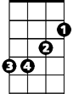


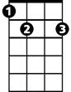

Intro: G Em Am7 D7
G
Am7
Em
Am
E7
A7

G Dm6 Am D7
Don't know why there's no sun up in the sky
G Em7
Stormy weather

Am7 D7 G Em
Since my gal and I ain't to-gether,
Am7 D7 G Em Am7 D7
Keeps rainin' all the time

G Dm6 Am D7
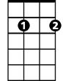
Life is bare, gloom and misery every-where
Em7
G Em7
Stormy weather
Am7 D7 G Em
Just can't get my poor self to--gether,
Am D7 G Em Am7 D7
I'm weary all the time
D7 G Em Am7 D7
So weary all the time

Am D7 G Em
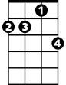



When she went away the blues walked in and met me.
Am7
BARITONE
G
Em
D7
Em7
E7
Am D7 G Em
If she stays away old rockin' chair will get me.
Am D7 G E7
All I do is pray the Lord above will let me,
A7 D7

Walk in the sun once more.
Am

G Dm6 Am D7
Can't go on, every thing I had is gone
G Em7
Stormy weather

Am7 D7 G Em
Since my gal and I ain't to-gether,
Am D7 G Em Am7 D7
Keeps rainin' all the ime
Am D7 G Em Am7 D7 G
Keeps rainin' all the time

