Stray Cat Strut (The Stray Cats)


G
Am
Intro: Am G F E7 (2x)
Oooh Oooh Oooh Oooh

Am G F E7 Am G F E7
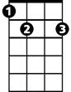

Black and orange stray cat sittin' on a fence.
E7
F
Am G F E7 Am G F E7
Ain't got enough dough to pay the rent.
Am G F E7 Am (tacet)
I'm flat broke but I don't care ~ I strut right by with my tail in the air.

Dm C Bb A7
Stray cat strut I'm a ladies’ cat,
Dm C Bb A7
I'm a feline Casanova hey man that's that.
Dm C Bb A7 Dm (tacet)



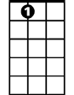
Get a shoe thrown at me from a mean old man ~ Get my dinner from a garbage can.
Dm
C
Bb
A7

(Instrumental) Am G F E7 (4x)

Dm Am
I don't bother chasing mice around.
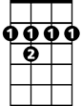
Dm
B7
I slink down the alley looking for a fight
B7 E7
Howlin' to the moonlight on a hot summer night.
Am G F E7
Singin' the blues while the lady cats cry.
Am G F E7
Wow stray cat you're a real gone guy.
Am G F E7 Am (tacet)
I wish I could be as care-free and wild ~ But I got cat class and I got cat style.

Am G F E7 (4x) Am
(repeat last verse )
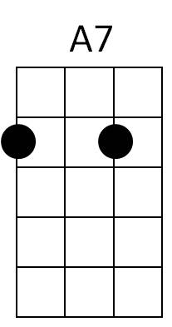
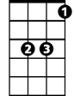

Am G F E7 (3x) Am G E7 Am
B7
Bb
C
Dm
E7
F
G
Am
BARITONE

