While Strolling Through the Park One Day (Ed Haley 1884)


C
G
G C
While strolling through th e park one day,
A7 D7
In the merry, merry month of May,
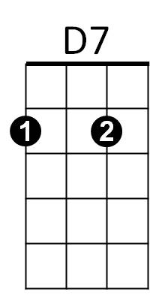
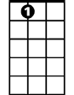
G C A7
A7
He was taken by surp rise by a pair of roguish eyes,
D7 G
In a moment his poor heart was stole away.

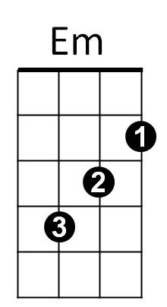
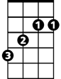
B Em B7 Em
B
A smile was all she gave to him,
A D A7 D
Of course she was as happy as can be,

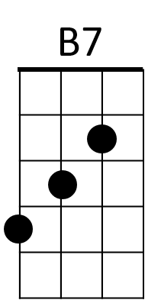
D
G C
He immediately raised his hat,
A7 D7
And finally she remarked,
G C A7
He never will forget that lovely afternoon,
D7 G
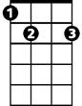

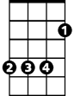

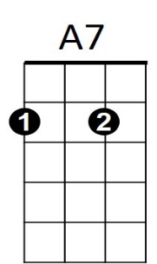

He met her at the fountain in the park.
D
B7
Em
B
D7
C
G
BARITONE

