Summertime (Gershwin Ira / Gershwin George / Heyward Du Bose)

Intro: Dm Am 4x

Am Dm Am Dm Am Dm Am
Summertime, and the livin' is easy
Dm E7 C7 E7
Fish are jumpin' and the cotton is high
Am Dm Am Dm Am Dm Am
Your daddy's rich, and your momma's good lookin'
C D7 E7 Am Dm Am
So hush little baby, don't you cry

Am Dm Am Dm Am Dm Am
One of these mornings, you're gonna rise up singing
D m E7 C7 E7
Then you'll spread your wings, and you'll take to the sky
Am Dm Am Dm Am Dm Am
But till that morning, there's a n othin' can harm you
C D7 E7 Am Dm Am
With daddy and mammy, standing by

Am Dm Am Dm Am Dm Am
Summertime, and the livin' is easy
Dm E7 C7 E7
Fish are jumpin' and the cotton is high
Am Dm Am Dm Am Dm Am
Your daddy's rich, and your momma's good lookin'
C D7 E7 Am Dm Am
So hush little baby, don't you cry
C D7 E7 Am Dm Am
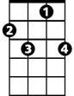
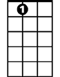



So hush little baby, don't you cry
BARITONE
C7
E7
Dm
Am
C


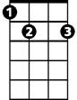

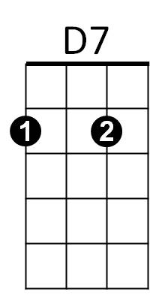

D7
Am
E7
C7
C
Dm

