Sundown (Gordon Lightfoot) Key A
Intro: A A7

A
I can see her lyin' back in her satin dress
E7 A
In a room where you do what you don't confess

D
Sundown you better take care
G A
If I find you've been creepin' 'round my back stairs
D
Sundown you better take care
G A
If I find you've been creepin' 'round my back stairs

A
She's been lookin' like a queen in a sailor's dream
E7 A
And she don't always say what she really means

D
Sometimes I think it's a shame
G A
When I get feelin' better when I'm feelin' no pain
D
Sometimes I think it's a shame
G A
When I get feelin' better when I'm feelin' no pain

A
I can picture every move that a man could make
E7 A
Getting lost in her lovin' is your first mistake

D
Sundown you better take care
G A
If I find you've been creepin' 'round my back stairs
D
Sometimes I think it's a sin
G A
When I feel like I'm winnin' when I'm losin’ again

A
I can see her lookin' fast in her faded jeans
E7 A
She's a hard lovin' woman, got me feelin' mean

D
Sometimes I think it's a shame
G A
When I get feelin' better when I'm feelin' no pain
D
Sundown you better take care
G A
If I find you've been creepin' 'round my back stairs
D
Sundown you better take care
G A
If I find you've been creepin' 'round my back stairs
D
Sometimes I think it's a sin
G A
When I feel like I'm winnin' when I'm losin' again

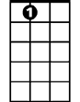
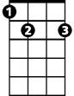
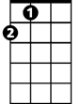
G
A7
E7
A


D

BARITONE
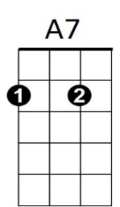

A
E7
D
G

Sundown (Gordon Lightfoot) Key C
Intro: C C7

C
I can see her lyin' back in her satin dress
G7 C
In a room where you do what you don't confess

F
Sundown you better take care
Bb C
If I find you've been creepin' 'round my back stairs
F
Sundown you better take care
Bb C
If I find you've been creepin' 'round my back stairs

C
She's been lookin' like a queen in a sailor's dream
G7 C
And she don't always say what she really means

F
Sometimes I think it's a shame
Bb C
When I get feelin' better when I'm feelin' no pain
F
Sometimes I think it's a shame
Bb C
When I get feelin' better when I'm feelin' no pain

C
I can picture every move that a man could make
G7 C
Getting lost in her lovin' is your first mistake

F
Sundown you better take care
Bb C
If I find you've been creepin' 'round my back stairs
F
Sometimes I think it's a sin
Bb C
When I feel like I'm winnin' when I'm losin’ again

C
I can see her lookin' fast in her faded jeans
G7 C
She's a hard lovin' woman, got me feelin' mean

F
Sometimes I think it's a shame
Bb C
When I get feelin' better when I'm feelin' no pain
F
Sundown you better take care
Bb C
If I find you've been creepin' 'round my back stairs
F
Sundown you better take care
Bb C
If I find you've been creepin' 'round my back stairs
F
Sometimes I think it's a sin
Bb C
When I feel like I'm winnin' when I'm losin' again


C7
C
G7



Bb
F

BARITONE
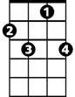
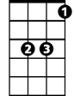
C7
G7
F
Bb
C

Sundown (Gordon Lightfoot) Key G
Intro: G G7

G
I can see her lyin' back in her satin dress
D7 G
In a room where you do what you don't confess

C
Sundown you better take care
F G
If I find you've been creepin' 'round my back stairs
C
Sundown you better take care
F G
If I find you've been creepin' 'round my back stairs

G
She's been lookin' like a queen in a sailor's dream
D7 G
And she don't always say what she really means

C
Sometimes I think it's a shame
F G
When I get feelin' better when I'm feelin' no pain
C
Sometimes I think it's a shame
F G
When I get feelin' better when I'm feelin' no pain

G
I can picture every move that a man could make
D7 G
Getting lost in her lovin' is your first mistake

C
Sundown you better take care
F G
If I find you've been creepin' 'round my back stairs
C
Sometimes I think it's a sin
F G
When I feel like I'm winnin' when I'm losin’ again

G
I can see her lookin' fast in her faded jeans
D7 G
She's a hard lovin' woman, got me feelin' mean

C
Sometimes I think it's a shame
F G
When I get feelin' better when I'm feelin' no pain
C
Sundown you better take care
F G
If I find you've been creepin' 'round my back stairs
C
Sundown you better take care
F G
If I find you've been creepin' 'round my back stairs
C
Sometimes I think it's a sin
F G
When I feel like I'm winnin' when I'm losin' again

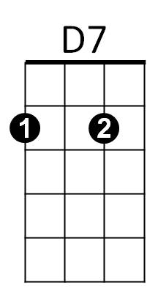
G
G7

F
C

BARITONE

G7
C
F
D7
G

