Sunny Afternoon (The Kinks)
Intro: Am G F E7

Am G
The taxman’s taken all my dough,
C G
And left me in my stately home.
E7 Am
Lazing on a sunny afternoon
G
And I can't sail my yacht,
C G
She’s taken everything I've got.
E7 Am E7
Lazing on a sunny afternoon.

A7 D7
Save me, save me, save me from this squeeze,
G G7 C E7
I got a big fat momma trying to break me.
Am D7
Because I love to live so pleasantly,
Am D7
In this life of luxury.
C E7 Am
Lazing on a sunny afternoon.
E7 Am E7
In the summer time, in the summer time.
Am E7 Am E7
In the summer time, in the summer time

Am G
My girlfriend’s run off with my car
C G
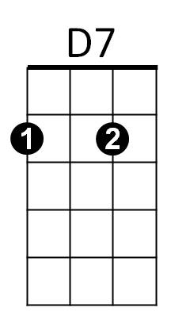




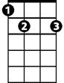

And gone back to her ma and pa's
G7
G
Am
F
E7
C
E7 Am
Telling tales of drunkenness and cruelty.
G
And now I'm sitting here,
C G
I'm sipping on my ice cold beer.
E7 Am E7
Lazing on a sunny afternoon.

BARITONE



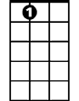
F
G
Am
C
E7
D7

A7 D7
Help me, help me, help me sail away,
G G7 C E7
Ah, give me two good reasons why I ought to stay.
Am D7
Because I love to live so pleasantly,
Am D7
In this life of luxury.
C E7 Am
Lazing on a sunny afternoon.
E7 Am E7
In the summer time, in the summer time.
Am E7 Am E7
In the summer time, in the summer time
.
A7 D7
Save me, save me, save me from this squeeze,
G G7 C E7
I got a big fat momma trying to break me.
Am D7
Because I love to live so pleasantly,
Am D7
In this life of luxury.
C E7 Am
Lazing on a sunny afternoon.
E7 Am E7
In the summer time, in the summer time.
Am E7 Am E7
In the summer time, in the summer time

Repeat last line to fade


G7

