
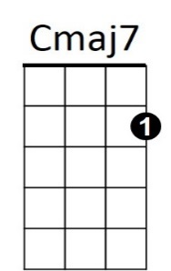

Sunny Skies (James Taylor)
Dm
C

Cmaj7 Dm Cmaj7 Dm
Sunny Skies sleeps in the morning, he doesn't know when to rise
Cmaj7 Dm Cmaj7
He closes his weary eyes upon the day

Dm Cmaj7 Dm Cmaj7
G7
Look at him yawning, throwing his morning hours away

Cmaj7 Dm G7 Cmaj7 Dm C
He knows how to ease down slowly, everything is fine in the end
Dm G7 Cmaj7 Dm G7
And you will be pleased to know that Sunny Skies hasn't a friend

Cmaj7 Dm Cmaj7 Dm
Sunny Skies weeps in the ev'nin', it doesn't much matter why
Cmaj7 Dm Cmaj7
I guess he just has to cry from time to time
Dm Cmaj7 Dm Cmaj7
Everyone's leavin', and Sunny Skies has to stay behind

Cmaj7 Dm G7 Cmaj7 Dm C
Still he knows how to ease down slow(ly), everything is fine in the end.
Dm G7 Cmaj7 Dm G7
And you will be pleased to know that Sunny Skies hasn't a friend
BARITONE

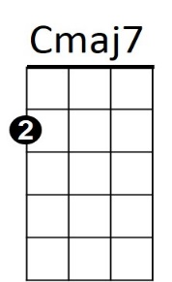


Dm
G7
C
Cmaj7 Dm Cmaj7 Dm
Sunny Skies sleeps in the morning, he doesn't know when to rise
Cmaj7 Dm Cmaj7
He closes his weary eyes upon the day
Dm Cmaj7 Dm Cmaj7
And throws it all away.

Dm G7 Cmaj7 Dm Cmaj7
Looking at the snow and trees that grow outside my window
Dm G7 Cmaj7 Dm Cmaj7
Looking at the things that pass me by.
Dm G7 Cmaj7 Dm Cmaj7 Dm Cmaj7
Wondering if where I've been is worth the things I've been through
Dm G7 Cmaj7
Ending with a friend named Sunny Skies.

