Sunny (Bobby Hebb, 1966)
Am C7 F E7

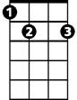



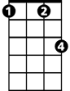
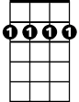
Sunny.. ..yesterday my life was filled with rain.
C
E7
Am
F
C7
Fm
Bm7
Am C7 F E7
Sunny.. ..you smiled at me and really eased the pain.
Am C
Oh, the dark days are done and the bright days are here,
F Fm
My sunny one shines so sincere.
Bm7 E7 Am E7
Oh, Sunny one so true, I love you.

Am C7 F E7
Sunny, thank you for the sunshine bouquet.
Am C7 F E7
Sunny, thank you for the love you brought my way.
Am C
You gave to me your all and all,
F Fm
Now I feel ten feet tall.
Bm7 E7 Am E7
Oh, Sunny one so true, I love you.

Am C7 F E7
Sunny.. . .thank you for the truth you've let me see.
Am C7 F E7
BARITONE
Sunny.. ..thank you for the facts from A to Z.
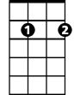
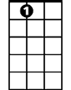

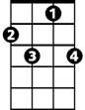

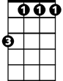
Am C
Bm7
E7
F
C7
Am
Fm
C
My life was torn like wind blown sand,
F Fm
Then a rock was formed when we held hands.
Bm7 E7 Am E7
Sunny one so true, I love you.

Am C7 F E7
Sunny, thank you for that smile upon your face.
Am C7 F E7
Sunny, thank you for that gleam that flows with grace.
Am C
You're my spark of nature's fire,
F Fm
You're my sweet complete desire.
Bm7 E7 Am
Sunny one so true, I love you.
Bm7 E7 Am
Sunny one so true, I love you.

Sunny (Bobby Hebb, 1966)
Dm F7 Bb A7
Bb
F7
Dm
Sunny.. ..yesterday my life was filled with rain.
Dm F7 Bb A7
Sunny.. ..you smiled at me and really eased the pain.
Dm F
Oh, the dark days are done and the bright days are here,
Bb Bbm
My sunny one shines so sincere.
Bbm
F
A7
Em7 A7 Dm A7
Oh, Sunny one so true, I love you.

Dm F7 Bb A7
Sunny, thank you for the sunshine bouquet.
Dm F7 Bb A7
Em7
Sunny, thank you for the love you brought my way.
Dm F
You gave to me your all and all,
Bb Bbm
Now I feel ten feet tall.
Em7 A7 Dm A7
Oh, Sunny one so true, I love you.

Dm F7 Bb A7
Sunny.. . .thank you for the truth you've let me see.
BARITONE
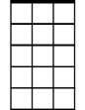
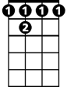
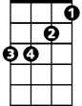
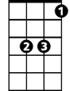

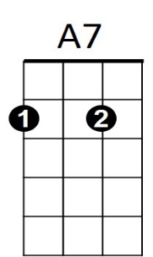
Dm F7 Bb A7
Em7
F7
Bbm
F
Bb
Dm
Sunny.. ..thank you for the facts from A to Z.
Dm F
My life was torn like wind blown sand,
Bb Bbm
Then a rock was formed when we held hands.
Em7 A7 Dm A7
Sunny one so true, I love you.

Dm F7 Bb A7
Sunny, thank you for that smile upon your face.
Dm F7 Bb A7
Sunny, thank you for that gleam that flows with grace.
Dm F
You're my spark of nature's fire,
Bb Bbm
You're my sweet complete desire.
Em7 A7 Dm
Sunny one so true, I love you.
Em7 A7 Dm
Sunny one so true, I love you.

