Sunrise, Sunset (Jerry Bock / Sheldon Harnick) Key Am

Am E7 Am E7
Is this the little girl I car - ried?
Am E7 Am A7
Is this the little boy at play?
Dm A7 Dm
I don't remember growing older –
B B7 E7
When did they?

Am E7 Am E7
When did she get to be a beau - ty?
Am E7 Am A7
When did he grow to be so tall?
Dm A7 Dm B7 E7
Wasn't it yesterday when they were small?
E7 E7+5 E7

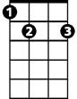
Chorus:
Am
E7
Am Dm Am E7
Sun-rise, sun-set,
Am Dm Am E7
Sun- rise, sun- set,
Am Dm Am Dm Am A7

Swift - ly flow the days;
G7
Dm G7 C Am
Seedlings turn overnight to sun - flow'rs,
Bm7 E7 Am
Blossoming even as we gaze.
E7 E7+5 E7

Am Dm Am E7
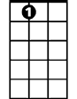
Sun-rise, sun-set,
E7
Am Dm Am E7
Sun- rise, sun- set,
Am Dm Am Dm Am A7
Swift-ly fly the years;
Dm G7 C Am
One season following anoth - er,
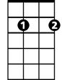
Dm E7 E7+5 Am
Bm7
Laden with hap-pi-ness...and tears.

Am E7 Am E7
What words of wisdom can I give them,
Am E7 Am A7
How can I help to ease their way?
Dm A7 Dm
Now they must learn from one another,
B B7 E7
Day by day.

Am E7 Am E7
They look so natural to-geth - er.
Am E7 Am A7
Just like two newlyweds should be.
Dm A7 Dm B7 E7
Is there a canopy in store for me?

(Chorus) (Extend last line) End with C6
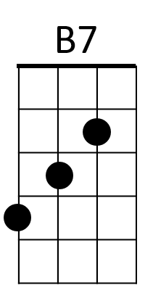
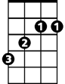

B
Dm
A7

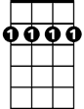

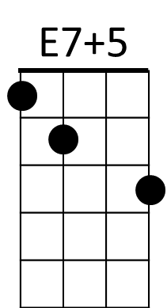
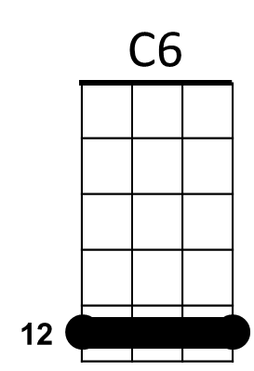
Bm7
C

BARITONE
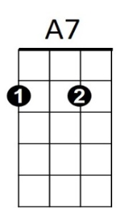
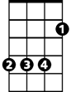

B
Dm
Am
B7

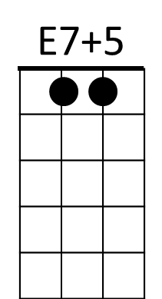


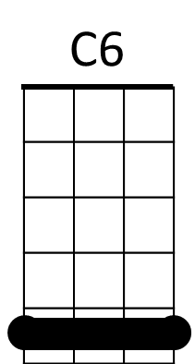
G7
C

Sunrise, Sunset (Jerry Bock / Sheldon Harnick) Key Dm

Dm A7 Dm A7
Is this the little girl I car - ried?
Dm A7 Dm D7
Is this the little boy at play?
Gm D7 Gm
I don't remember growing older –
Em7 E7 A7
When did they?

Dm A7 Dm A7
When did she get to be a beau - ty?
Dm A7 Dm D7
When did he grow to be so tall?
Gm D7 Gm E7 A7
Wasn't it yesterday when they were small?
A7 A7+5 A7
Dm
Chorus:
Dm Gm Dm A7
Sun-rise, sun-set,
Dm Gm Dm A7
Sun- rise, sun- set,
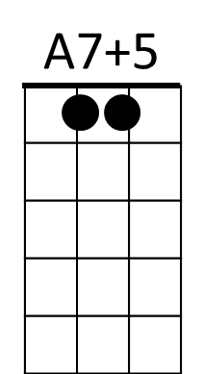
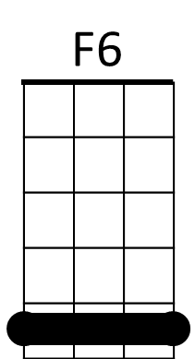
Dm Gm Dm Gm Dm D7
E7
Swift - ly flow the days;
Gm C7 F Dm
Seedlings turn overnight to sun - flow'rs,
Em7 A7 Dm
Blossoming even as we gaze.

Dm Gm Dm A7
BARITONE
Sun-rise, sun-set,
Dm Gm Dm A7
Sun- rise, sun- set,
Dm Gm Dm Gm Dm D7
Swift-ly fly the years;
Gm C7 F Dm
One season following anoth - er,
Gm A7 A7+5 Dm
E7
Laden with hap-pi-ness..and tears.

Dm A7 Dm A7
What words of wisdom can I give them,
Dm A7 Dm D7
How can I help to ease their way?
Gm D7 Gm
Now they must learn from one another,
Em7 E7 A7
Day by day.

Dm A7 Dm A7
They look so natural to-geth - er.
Dm A7 Dm D7
Just like two newlyweds should be.
Gm D7 Gm E7 A7
Is there a canopy in store for me?

(Chorus) (Extend last line) End with F6
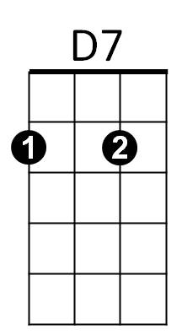
A7
Gm
Em7

C7
F

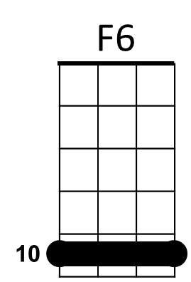

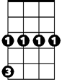
Dm
Em7
Gm
D7


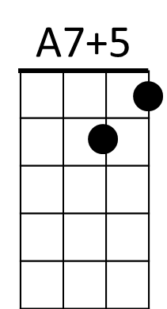
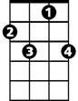
F
C7

