Surf City (Brian Wilson / Jan Berry)



C F G E7
F
C
Two girls for eve - ry boy
A
I bought a '30 Ford wagon
F#m
and we call it a woody
A F#m

Surf City, here we come
G
A
You know it's not very cherry,
F#m
It's an oldie but a goodie
A F#m
Surf City, here we come
D Bm
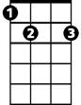
Well, it ain't got a back seat or a rear window
E7
G E7
But it still gets me where I wanna go

Chorus:
A
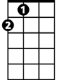
And we're goin' to Surf City,
A
'cause it's two to one
You know we're goin' to Surf City,
gonna have some fun
D
You know we're goin' to Surf City,
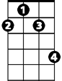
'cause it's two to one
F#m
A
You know we're goin' to Surf City,
gonna have some fun, now
C F G E7
Two girls for eve - ry boy


A
BARITONE
D
They say they never roll the streets up
F#m
'Cause there's always somethin' goin'
A F#m
Surf City, here we come
A
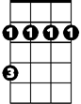
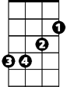
You know they're either out surfin'
F#m
D
Bm
F#m
Or they got a party growin'
A F#m
Surf City, here we come
D Bm
And there's two swingin' honeys for every guy
G E7
And all you gotta do is just wink your eye

(Chorus)
Bm

A
And if my woody breaks down on me
F#m
Somewhere on the surf route
A F#m

Surf City, here we come
Bb
A
I'll strap my board to my back
F#m
And hitch a ride in my wetsuit
A F#m
Surf City, here we come
D Bm
And when I get to Surf City I'll be shootin' the curl
G E7
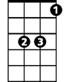
And checkin' out the parties for a surfer girl
Eb

A
And we're goin' to Surf City,
'cause it's two to one
You know we're goin' to Surf City,
gonna have some fun
D
You know we're goin' to Surf City,
'cause it's two to one
A
You know we're goin' to Surf City,
gonna have some fun, now
C F Bb Eb G
Two girls for every - Two girls for every boy
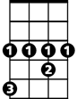
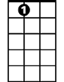
Eb
Bb
A
E7
C
F
G

