SUSIE Q (Hawkins/Lewis/Broadwater) Key A



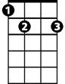
Intro: (7 measures of A7)
A7
D
E7

A7
Oh Susie Q, oh Susie Q
D F7 E7 A7
Oh Susie Q, baby I love you - Susie Q
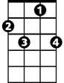
F7
A7
I like the way you walk, I like the way you talk
D F7
I like the way you walk, I like the way you talk
E7 A7
Susie Q

[Instrumental] (pattern of 2 verses, then 7 measures of A7)

A7
Say that you'll be true, say that you'll be true
D F7
Say that you'll be true and never leave me blue
E7 A7

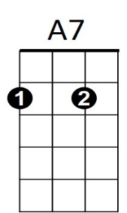
Susie Q
D
BARITONE

A7
Say that you'll be mine, say that you'll be mine
D F7
Say that you'll be mine, baby, all the time
E7 A7
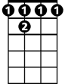
Susie Q
F 7
E7

[Repeat Verse 1/2]

[Repeat Verse 1] (sing 1 octave higher)

Outro:

A7 (to fade)
Oh Susie Q

