Suzanne (Leonard Cohen)


C
C
Suzanne takes you down
To her place near the river
Dm
You can hear the boats go by,
You can spend the night beside her
C

And you know that she's half-crazy,
F
but that's why you wanna be there
Em
And she feeds you tea and oranges
F
That come all the way from China
C

And just when you mean to tell her
Dm
Dm
That you have no love to give her
C
Then she gets you on her wavelength
Dm
And she lets the river answer
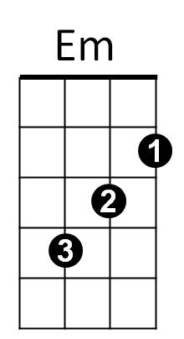
C
That you've always been her lover

Em
And you want to travel with her,
F
And you want to travel blind
C
And you know that she will trust you,
F C
For you've touched her perfect body with your mind

C
And Jesus was a sailor,
when he walked upon the water
Dm
And he spent a long time watching
from his lonely wooden tower
C
And when he knew for certain only drowning men could see him, he said,
Em
'All men will be sailors then,
F
BARITONE
Until the sea shall free them'
C
But he himself was broken,
Dm
Long before the sky would open
C
Forsaken, almost human,
Dm C
He sank beneath your wisdom like a stone

Em
And you want to travel with him,
F
And you want to travel blind
C
And you think maybe you'll trust him,
F C
For he's touched your perfect body with his mind
C
Now Suzanne takes your hand
and she leads you to the river
Dm
She is wearing rags and feathers
from Salvation Army counter
C
And the sun pours down like honey
on Our Lady of the Harbor
Em
And she shows you where to look
F
Among the garbage and the flowers
C
There are heroes in the seaweed,
Dm
There are children in the morning
C
They are leaning out for love,
Dm
And they will lean that way forever
C
While Suzanne holds the mirror

Em
And you want to travel with her,
F
and you want to travel blind
C
And you know you can trust her,
F C
For she's touched your perfect body with her mind



C
Em
Dm
F

