Sweet Georgia Brown
(Ben Bernie, Maceo Pinkard, Kenneth Casey)

Intro: (Chords for Reprise)

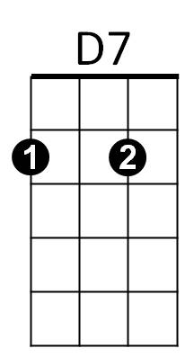
G7
D7
No gal made has got a shade on ….sweet Georgia Brown
G7
Two left feet but oh so neat has sweet Georgia Brown
C7
They all sigh and wanna’ die for…sweet Georgia Brown


F A7
F
C7
I’ll tell you just why, you know I won’t lie (not much!)

D7
It’s been said she knocks ‘em dead when she lands in town
G7
Since she came, why it’s a shame how she cools ‘em down

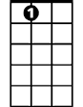
Dm
A7
Dm A7 Dm A7
Fellas she can’t get are fellas she ain’t met
F D7
Georgia claimed her, Georgia named her
G7 C7 F
Sweet Georgia Brown

D7
No gal made has got a shade on ….sweet Georgia Brown
BARITONE
G7
D7
G7
Two left feet but oh so neat has sweet Georgia Brown
C7
They all sigh and wanna’ die for…sweet Georgia Brown
F A7
I’ll tell you just why, you know I won’t lie (not much!)

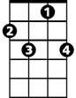
F
C7
D7
All those gifts the courters give to sweet Georgia Brown
G7
They buy clothes at fashions shows, with one dollar down


Dm A7 Dm A7
Dm
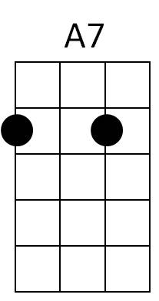
Oh boy, tip your hat! Oh joy, she’s the cat!
F D7 G7 C7 F
Who’s that mister? ‘Tain’t no sister, Sweet Georgia Brown
F D7 G7 C7 F
Georgia claimed her, Georgia named her, Sweet Georgia Brown

