Sweet Violets (Charles Green / Cy Coben) (C)

C G7
There once was a farmer who took a young miss, In back of the barn where he gave her a -
C G7
Lecture on horses and chickens and eggs, And told her that she has such beautiful -
C G7
Manners that suited a girl of her charms, A girl that he'd like for to take in his -
C G7
Washing and ironing, and then if she did, They could get married and raise lots of -

Chorus
C G7
Sweet violets, sweeter than all the roses, Covered all over from head to toe,
C F C
Covered all over with sweet vio-lets.

C G7
The girl told the farmer that he'd better stop, And she told her father and called a-
C G7
Taxi which got there before very long, For someone was doing his little girl -
C G7
Right for a change, and so here's what he said: "If you marry her, son, you're better off -
C G7
Single 'cause it's been my belief, All a man gets out of marriage is - Chorus

C G7
The farmer decided he'd wed anyway, And started in planning for his wedding -
C G7
Suit which he'd purchased for only one buck, But then he found out he was just out of -
C G7
Money and so he got left in the lurch, Standing and waiting in front of the -
C G7
End of this story, which just goes to show, All a girl wants from a man is his – Chorus

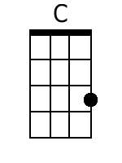 | 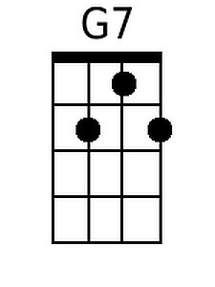 | 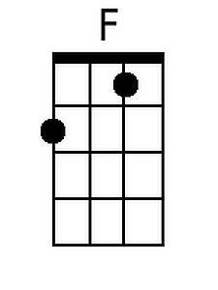 |  | Bari | 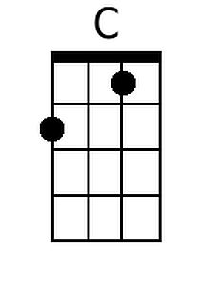 | 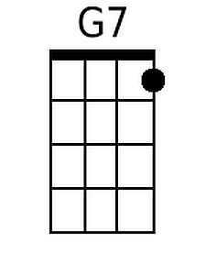 | 