Sweet Violets (Charles Green / Cy Coben)

G D7
There once was a farmer who took a young miss
In back of the barn where he gave her a -

G D7
Lecture on horses and chickens and eggs,
And told her that she has such beautiful -

G D7
Manners that suited a girl of her charms,
A girl that he'd like for to take in his -

G D7
Washing and ironing, and then if she did,
They could get married and raise lots of -

Chorus:
G D7
Sweet violets, sweeter than all the roses,
Covered all over from head to toe,
G C G
Covered all over with sweet vio-lets.

G D7
The girl told the farmer that he'd better stop,
And she told her father and called a-

G D7
Taxi which got there before very long,
For someone was doing his little girl –
BARITONE



D7
C
G
G D7
Right for a change, and so here's what he said:
"If you marry her, son, you're better off –

G D7
Single 'cause it's been my belief,
All a man gets out of marriage is-

(Chorus)

G D7
The farmer decided he'd wed anyway,
And started in planning for his wedding –

G D7
Suit which he'd purchased for only one buck,
But then he found out he was just out of -

G D7
Money and so he got left in the lurch,
Standing and waiting in front of the –

G D7
End of this story, which just goes to show,
All a girl wants from a man is his-

(Chorus)
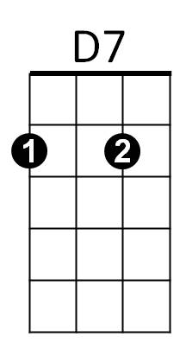

C
G

