Take This Job And Shove It (David Allen Coe)
Chorus:

TACET
Take this job and shove it
F
I ain't working here no more
C
My woman done left took all the reason
D7 G7
I was working for
C
Ya better not try to stand in my way
F C
As I'm walking out that door
F C
You can take this job and shove it
G7 C
I ain't working here no more

C
Well I been working in this factory

For now on fifteen years
F
All this time I watched my woman
G7
Drowning in a pool of tears
C
And I've seen a lot of good folks die
F C
Who had a lot of bills to pay
F C
I'd give the shirt right off of my back
BARITONE
G C
If I had the guts to say –

(Chorus)

C
The foreman he's a regular dog

The line boss he's a fool
F
He got a brand new flat top haircut
G7
Lord he thinks he's cool
C
One of these days I'm gonna blow my top
F C
And that sucker he's gonna pay
F C
I can't wait to see their faces
G C
When I get the nerve to say-

(Chorus)






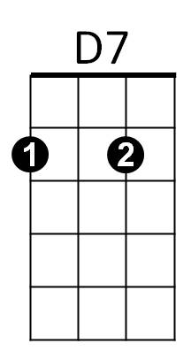
D7
C
G7
F
F
C
G7

