Tennessee Stud (James Driftwood)
G
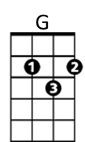
Along about eighteen twenty-five,
F
I left Tennessee very much alive
G
And I never would have gotten through the Arkansas mud
Dm G
If I hadn't been a-ridin' that Tennessee stud

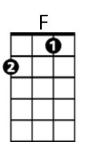
G
I had some trouble with my sweetheart's pa,
F
And one of her brothers was a bad outlaw
G
I sent her a letter by my Uncle Fud
Dm G
Then I rode away on the Tennessee stud


CHORUS:
Dm
G F G
The Tennessee stud was long and lean
C Bb D
The color of the sun and his eyes were green
G F G
He had the nerve and he had the blood
(tacet)
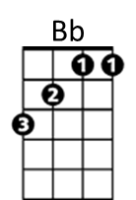
And there never was a horse like the Tennessee stud

G
We drifted on down into no man's land
F
We crossed that river called the Rio Grande
G
I raced my horse with a Spaniard's foal
Dm G
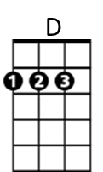
'Til I got me a skin full of silver and gold

G
Me and the gambler, we couldn't agree
F
We got in a fight over Tennessee
G
We jerked our guns and he fell with a thud
Dm G
And I got away on the Tennessee stud

(CHORUS)

G
Well, I got just as lonesome as a man can be
F
A-dreaming of my girl in Tennessee
G
The Tennessee stud's green eyes turned blue
Dm G
BARITONE


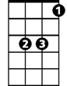


'Cause he was a-dreamin' of his sweetheart, too
F
G
Bb
Dm
D

G
We loped right back across Arkansas
F
I whooped her brother and I whooped her pa
G
When I found that girl with the golden hair
Dm G
And she was a-ridin' that Tennessee mare (whoa, boy)

(CHORUS)

G
Stirrup to stirrup and side by side
F
We crossed them mountains and the valleys wide
G
We came to Big Muddy then we forded a flood
Dm G
On the Tennessee mare and the Tennessee stud

G
There's a pretty little baby on the cabin floor
F
A little horse colt playin' 'round the door
G
I love that girl with golden hair
Dm G
And the Tennessee stud loves the Tennessee mare (They'se good horses)

(CHORUS)

Tennessee Stud (James Driftwood) Key A
A
Along about eighteen twenty-five,
G
I left Tennessee very much alive
A
And I never would have gotten through the Arkansas mud
Em A
If I hadn't been a-ridin' that Tennessee stud

A
I had some trouble with my sweetheart's pa,
G
And one of her brothers was a bad outlaw
A
I sent her a letter by my Uncle Fud
Em A
Then I rode away on the Tennessee stud

CHORUS:
Dm
A G A
The Tennessee stud was long and lean
D C E
The color of the sun and his eyes were green
A G A
He had the nerve and he had the blood
(tacet)
And there never was a horse like the Tennessee stud

A
We drifted on down into no man's land
G
We crossed that river called the Rio Grande
A
I raced my horse with a Spaniard's foal
Em A
'Til I got me a skin full of silver and gold

A
Me and the gambler, we couldn't agree
G
We got in a fight over Tennessee
A
We jerked our guns and he fell with a thud
Em A
And I got away on the Tennessee stud

(CHORUS)

A
Well, I got just as lonesome as a man can be
G
A-dreaming of my girl in Tennessee
A
The Tennessee stud's green eyes turned blue
Em A
BARITONE
'Cause he was a-dreamin' of his sweetheart, too
F
G
Bb
Dm
D

A
We loped right back across Arkansas
G
I whooped her brother and I whooped her pa
A
When I found that girl with the golden hair
Em A
And she was a-ridin' that Tennessee mare (whoa, boy)

(CHORUS)

A
Stirrup to stirrup and side by side
G
We crossed them mountains and the valleys wide
A
We came to Big Muddy then we forded a flood
Em A
On the Tennessee mare and the Tennessee stud

A
There's a pretty little baby on the cabin floor
G
A little horse colt playin' 'round the door
A
I love that girl with golden hair
Em A
And the Tennessee stud loves the Tennessee mare (They'se good horses)

(CHORUS)

