Tequila Sunrise (Don Henly / Glenn Frey) Key C

Intro: Chords for ending

C
It's another tequila sunrise
G Dm
Starin' slowly cross the sky -
G7 C
I said good-bye.

C
He was just a hired hand
G Dm
Workin' on the dreams he planned to try -
G7 C
The days go by

Am F
Every night when th e sun goes down
Am F Am
Just another lonely boy in town
Dm G7
And she's out runnin' rou - nd

C
She wasn’t just another woman
G Dm
And I couldn’t keep from coming' on -
G7 C
It's been so long

C
Oh and it's a hollow feelin'
G Dm
When it comes down to dealin' friends -
BARITONE
G7 C
It never ends.

Instrumental verse

Dm G
Take another shot of courage
Em Am Dm
Wonder why the right words never come -
E7 Am7 D
You just get numb

Ending:
C
It's another tequila sunrise
G Dm
This old world still looks the same ~
G7 C
Another frame.

(strum C to fade)

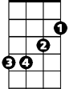
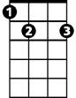
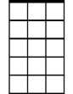






G
Em
E7
Am7
D
F
Am
G7
Dm
C



Am
G7
Dm
G
C

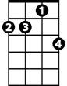
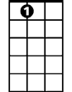

D
Em
Am7
E7
F

Tequila Sunrise (Don Henly / Glenn Frey) Key G
Intro: Chords for ending

G
It's another tequila sunrise
D Am
Starin' slowly cross the sky -
D7 G
I said good-bye.

G
He was just a hired hand
D Am
Workin' on the dreams he planned to try -
D7 G
The days go by

Em C
Every night when the sun goes down
Em C Em
C
Just another lonely boy in town
Am D7
And she's out runnin' rou - nd

G
She wasn’t just another woman
Em
D Am
And I couldn’t keep from coming' on -
D7 G
It's been so long

G
Oh and it's a hollow feelin'
D Am
BARITONE
When it comes down to dealin' friends
G
D7 G
It never ends.
Am D
Take another shot of courage
Bm Em Am
Wonder why the right words never come -
B7 Em7 A
You just get numb

Ending:
G
It's another tequila sunrise
D Am
This old world still looks the same ~
D7 G
Another frame.

Strum G to fade
G
D
Am
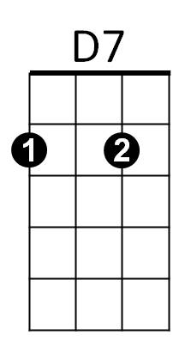

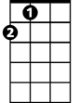
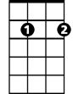
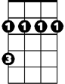
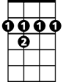
A
Em7
Bm
B7

D
Am
D7
Em

Instrumental verse

C
Bm
B7
Em7
A

