The Addams Family Theme (Vic Mizzy) UBA
X X X X X X
0 1 0 2 3 0 2 3 0 2 3 0 1
0 2 2 2 2 0 2

G C E A
X = Snap Fingers


C7 F Gm7
F
C7
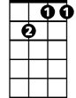
They're creepy and they're kooky
Gm7
C7 F
Mysterious and spooky
F Gm7
They're altogether ooky
C7 F
The Addams fam ily

F Gm7
Their house is a museum
C7 F
When people come to see 'em
F Gm7
They really are a scre-am
C7 F
The Addams family

Neat ………… Sweet Petite
X X X X X X
0 1 0 2 3 0 2 3 0 2 3 0 1
0 2 2 2 2 0 2

G C E A


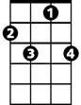
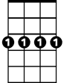
C7 F Gm7
F
C7
Gm7
BARITONE
So get a witch's shawl on
C7 F
A broomstick you can crawl on
F F
We're gonna pay a call on
C7 F X X
(Slower) The Ad-dams fami- ly
X X X X X X
0 1 0 2 3 0 2 3 0 2 3 0 1
1 3 3 3 3 1 3

D G B E A

