The Ballad of Thunder Road (Don Raye / Robert Mitchum) (G)

G  Let me tell the story, I can tell it all;  Am D7 G  About the mountain boy who ran illegal alcohol.  G  His daddy made the whiskey,  the son he drove the load;  Am D7  And when his engine roared  G Am G  They called the highway "Thunder Road".  G  Sometimes into Ashville,  Sometimes Memphis town.  Am D7  The Revenuers chased him  G  But they couldn't run him down.  G  Each time they thought they had him  His engine would explode.  Am D7  He'd go by like they were standing  G Am G  Still on "Thunder Road".  Chorus:  C  And there was thunder, thunder  G C D7  Over "Thunder Road", Thunder was his engine  G G7  And white lightening was his load.  C  And there was moonshine, moonshine  G  To quench the devil's thirst.  Am D7  The law they swore they'd get him  G  But the devil got him first.  G  It was on the first of April, Nineteen-Fifty-Four  Am D7  The Federal man sent word  G  He'd better make his run no more.  G  He said "200 agents were covering the state; |  |  |  | Am D7  Which ever road he tried to take  G Am G  They'd get him sure as fate."  G  'Son' his daddy told him, 'make this run your last.  Am D7  The tank is filled with 100 proof;  G  You're all tuned-up and gassed.  G  Now don't take any chances, if you can't get through.  Am D7  I'd rather have you back again  G Am G  Than all that Mountain Dew.' Chorus  G  Roaring out of Harlan; revving up his mill.  Am D7  He shot the Gap at Cumberland  G  And streamed by Maynardville.  G  With G men on his tail light; road block up ahead,  Am D7  The mountain boy took roads  G Am G  That even angels fear to tread.  G  Blazing right through Knoxville, out on Kingston Pike,  Am D7  Then right outside of Bearden,  G  They made the fatal strike.  G  He left the road at 90; that's all there is to say,  Am D7  The devil got the moonshine  G Am G  And the mountain boy that day. Chorus (2X)  Am D7  The law they swore they'd get him  C Am G  But the devil got him first. |  |  |  | 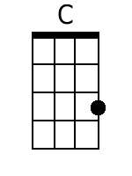
 |  |  |  |  |  |  |  | 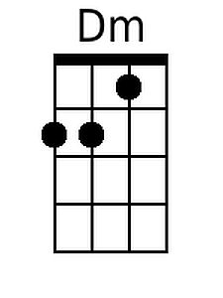
 |  |  |  |  |  |  |  | 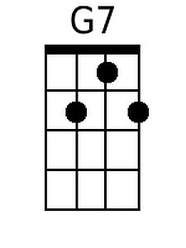
 |  |  |  |  |  |  |  | 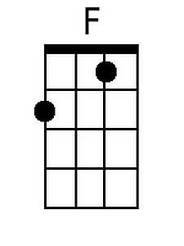
 |  |  |  |  |  |  |  | 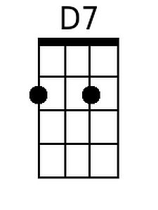
Bari | 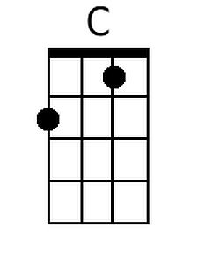 | 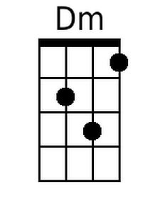 | 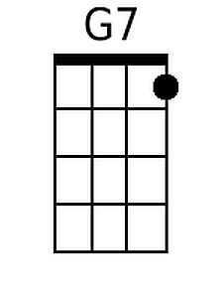 |  | 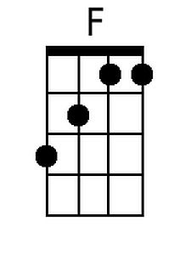 | 