The Battle of New Orleans (Jimmy Driftwood, ca. 1959) (C)

Strum in on C  C F  In 1814 we took a little trip  G7 C  A-long with Col. Jackson down the mighty Mississip'  F  We took a little bacon and we took a little beans  G7 C  And we caught the bloody British in a town in New  Orleans.  Chorus  C  We fired our guns and the British kept a comin'  G7 C  There wasn't nigh as many as there was a while a-go  F  We fired once more and they began to runnin'  G7 C  On down the Mississippi to the Gulf of Mex-i-co.  C F  We looked down the river and we see'd the British come  G7 C  And there musta been a hund'erd of 'em beatin' on the  drum  F  They stepped so high and they made their bugles ring  G7 C  We stood beside our cotton bales and didn't say a thing. Chorus |  |  |  |  | C F  Old Hick'ry said we could take 'em by su'prise  G7 C  If we didn't fire our musket till we looked 'em in the eyes  F  We held our fire till we see'd their faces well  G7 C  Then we opened up with squirrel guns and really gave  'em Well - Chorus  Bridge  C  Yeah! they ran through the briars and they ran through  the brambles  And they ran through the bushes  G7 C  Where a rabbit couldn't go  They ran so fast that the hounds couldn't catch 'em  G7 C  On down the Mississippi to the Gulf of Mex-i-co.  C F  We fired our cannon till the barrel melted down  G7 C  So we grabbed an alligator and we fought another round  F  We filled his head with cannonballs and powdered his  behind  G7 C  And when we touched the powder off, the 'gator lost his  mind. Chorus Bridge
GCEA | 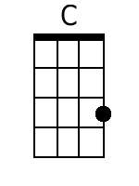 | 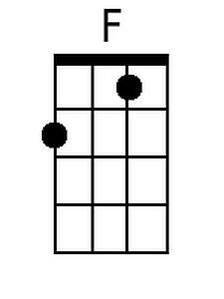 | 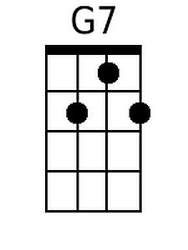 |  |  | DGBE | 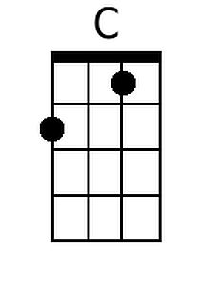 | 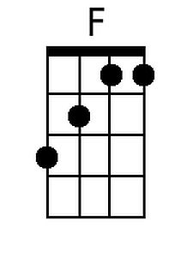 | 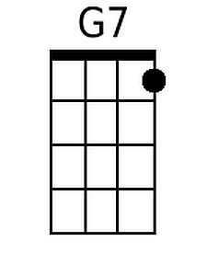

The Battle of New Orleans (Jimmy Driftwood, ca. 1959) (G)

Strum in on G

G C
In 1814 we took a little trip
D7 G
A-long with Col. Jackson down the mighty Mississip'
C
We took a little bacon and we took a little beans
D7 G
And we caught the bloody British in a town in New
Orleans.

Chorus
G
We fired our guns and the British kept a comin'
D7 G
There wasn't nigh as many as there was a while a-go
C
We fired once more and they began to runnin'
D7 G
On down the Mississippi to the Gulf of Mex-i-co.

G C
We looked down the river and we see'd the British come
D7 G
And there musta been a hund'erd of 'em beatin' on the
drum
C
They stepped so high and they made their bugles ring
D7 G
We stood beside our cotton bales and didn't say a thing. Chorus

G C
Old Hick'ry said we could take 'em by su'prise
D7 G
If we didn't fire our musket till we looked 'em in the eyes
C
We held our fire till we see'd their faces well
D7 G
Then we opened up with squirrel guns and really gave
'em Well - Chorus

Bridge
G
Yeah! they ran through the briars and they ran through
the brambles
And they ran through the bushes
D7 G
Where a rabbit couldn't go

They ran so fast that the hounds couldn't catch 'em
D7 G
On down the Mississippi to the Gulf of Mex-i-co.

G C
We fired our cannon till the barrel melted down
D7 G
So we grabbed an alligator and we fought another round
C
We filled his head with cannonballs and powdered his
behind
D7 G
And when we touched the powder off, the 'gator lost his
mind. Chorus Bridge

GCEA | 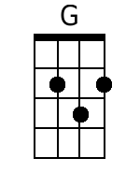 |  | 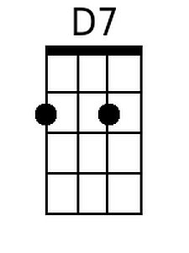 |  | DGBE | 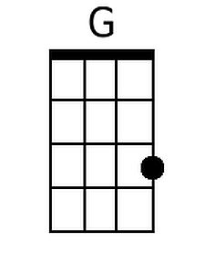 |  | 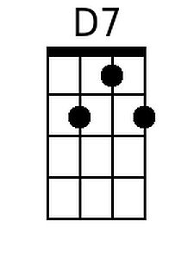

The Battle of New Orleans (Jimmy Driftwood, ca. 1959) (NN)

Strum in on 1  1 4  In 1814 we took a little trip  5(7) 1  A-long with Col. Jackson down the mighty Mississip'  4  We took a little bacon and we took a little beans  5(7) 1  And we caught the bloody British in a town in New  Orleans.  Chorus  1  We fired our guns and the British kept a comin'  5(7) 1  There wasn't nigh as many as there was a while a-go  4  We fired once more and they began to runnin'  5(7) 1  On down the Mississippi to the Gulf of Mex-i-co.  1 4  We looked down the river and we see'd the British come  5(7) 1  And there musta been a hund'erd of 'em beatin' on the  drum  4  They stepped so high and they made their bugles ring  5(7) 1  We stood beside our cotton bales and didn't say a thing. Chorus  1 4  Old Hick'ry said we could take 'em by su'prise  5(7) 1  If we didn't fire our musket till we looked 'em in the eyes  4  We held our fire till we see'd their faces well  5(7) 1  Then we opened up with squirrel guns and really gave  'em Well - Chorus | Bridge  1  Yeah! they ran through the briars and they ran through  the brambles  And they ran through the bushes  5(7) 1  Where a rabbit couldn't go  They ran so fast that the hounds couldn't catch 'em  5(7) 1  On down the Mississippi to the Gulf of Mex-i-co.  1 4  We fired our cannon till the barrel melted down  5(7) 1  So we grabbed an alligator and we fought another round  4  We filled his head with cannonballs and powdered his  behind  5(7) 1  And when we touched the powder off, the 'gator lost his  mind. Chorus Bridge
 | 1 | 4 | 5(7)
 | A | D | E7
 | C | F | G7
 | D | G | A7
 | F | Bb | C7
 | G | C | D7

Strum in on G

G C
In 1814 we took a little trip
D7 G
A-long with Col. Jackson down the mighty Mississip'
C
We took a little bacon and we took a little beans
D7 G
And we caught the bloody British in a town in New
Orleans.

Chorus
G
We fired our guns and the British kept a comin'
D7 G
There wasn't nigh as many as there was a while a-go
C
We fired once more and they began to runnin'
D7 G
On down the Mississippi to the Gulf of Mex-i-co.

G C
We looked down the river and we see'd the British come
D7 G
And there musta been a hund'erd of 'em beatin' on the
drum
C
They stepped so high and they made their bugles ring
D7 G
We stood beside our cotton bales and didn't say a thing. Chorus

G C
Old Hick'ry said we could take 'em by su'prise
D7 G
If we didn't fire our musket till we looked 'em in the eyes
C
We held our fire till we see'd their faces well
D7 G
Then we opened up with squirrel guns and really gave
'em Well - Chorus

Bridge
G
Yeah! they ran through the briars and they ran through
the brambles
And they ran through the bushes
D7 G
Where a rabbit couldn't go

They ran so fast that the hounds couldn't catch 'em
D7 G
On down the Mississippi to the Gulf of Mex-i-co.

G C
We fired our cannon till the barrel melted down
D7 G
So we grabbed an alligator and we fought another round
C
We filled his head with cannonballs and powdered his
behind
D7 G
And when we touched the powder off, the 'gator lost his
mind. Chorus Bridge

