The Boxer (Paul Simon, 1968) (C)

Intro: Cadd9 | Cadd9 | C | C |  C G Am  I am just a poor boy, though my story's seldom told.  G G7  I have squandered my resistance, for a pocket full of mumbles,  C G Am  Such are promises. All lies and jests,  G F C | G | G | G | C | C | C  Still a man hears what he wants to hear, and disregards the rest.  C G Am  When I left my home and my family, I was no more than a boy  G G7  In the company of strangers, in the quiet of the railway station.  C Am G F  Running scared. Laying low, seeking out the poorer quarters  C G F Em Dm C  Where the ragged people go, looking for the places only they would know.  Bridge  Am Em  Lie-la-lie, Lie-la-lie, la lie-la-lie,  Am G C | C | C  Lie-la-lie, Lie-la-lie, la la la la lie.  C G Am  Asking only workman's wages, I come looking for a job,  G G7 C  But I get no offers. Just a come-on from the whores on Seventh Avenue.  G Am G F  I do de-clare there were times when I was so lonesome  C G | C | C | C  I took some comfort there. Ooo-la-la, la-la la la.  (Instrumental Verse) (Chorus)  C G Am G  Then I'm laying out my winter clothes and wishing I was gone, going home.  G C Em Am G  Where the New York City winters are-n't bleeding me, Leading me, going home.  | G7 | G7 | C | C | C |  C G Am  In the clearing stands a boxer and a fighter by his trade  G G7  And he carries the reminders of every glove that laid him down  C G Am  Or cut him 'til he cried out iIn his anger and his shame  G F C | C C G C | G | F | C  "I am leaving, I am leaving" - but the fighter still re-mains.  Chorus (Repeat 8 times) | GCEA
 | 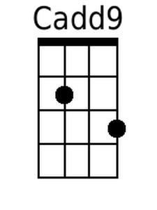
 | 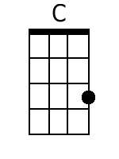
 | 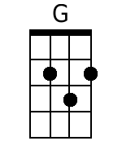
 | 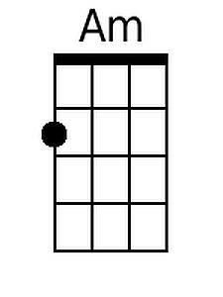
 | 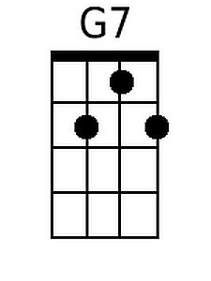
 | 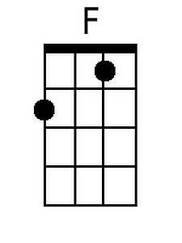
 | 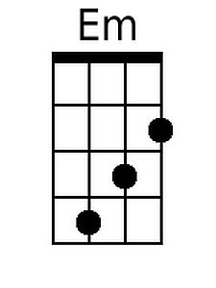
 | 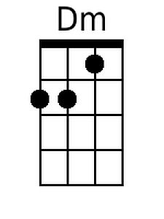

The Boxer (Paul Simon, 1968) (C)

Intro: Cadd9 | Cadd9 | C | C |  C G Am  I am just a poor boy, though my story's seldom told.  G G7  I have squandered my resistance, for a pocket full of mumbles,  C G Am  Such are promises. All lies and jests,  G F C | G | G | G | C | C | C  Still a man hears what he wants to hear, and disregards the rest.  C G Am  When I left my home and my family, I was no more than a boy  G G7  In the company of strangers, in the quiet of the railway station.  C Am G F  Running scared. Laying low, seeking out the poorer quarters  C G F Em Dm C  Where the ragged people go, looking for the places only they would know.  Bridge  Am Em  Lie-la-lie, Lie-la-lie, la lie-la-lie,  Am G C | C | C  Lie-la-lie, Lie-la-lie, la la la la lie.  C G Am  Asking only workman's wages, I come looking for a job,  G G7 C  But I get no offers. Just a come-on from the whores on Seventh Avenue.  G Am G F  I do de-clare there were times when I was so lonesome  C G | C | C | C  I took some comfort there. Ooo-la-la, la-la la la.  (Instrumental Verse) (Chorus)  C G Am G  Then I'm laying out my winter clothes and wishing I was gone, going home.  G C Em Am G  Where the New York City winters are-n't bleeding me, Leading me, going home.  | G7 | G7 | C | C | C |  C G Am  In the clearing stands a boxer and a fighter by his trade  G G7  And he carries the reminders of every glove that laid him down  C G Am  Or cut him 'til he cried out iIn his anger and his shame  G F C | C C G C | G | F | C  "I am leaving, I am leaving" - but the fighter still re-mains.  Chorus (Repeat 8 times) | Baritone
 | 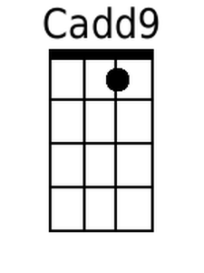
 | 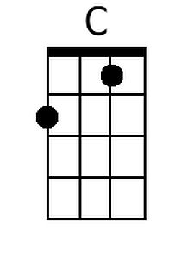
 | 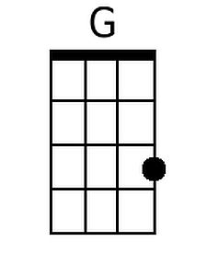
 | 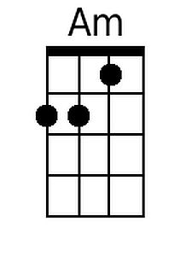
 | 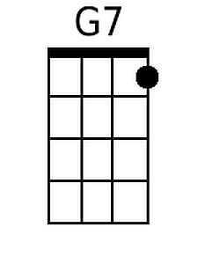
 | 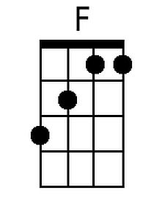
 | 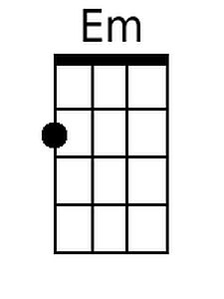
 | 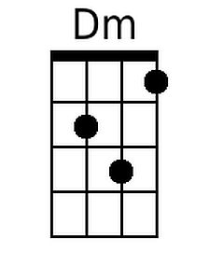

The Boxer (Paul Simon, 1968) (G)

Intro: Gadd9 | Gadd9 | G | G |  G D Em  I am just a poor boy, though my story's seldom told.  D D7  I have squandered my resistance, for a pocket full of mumbles,  G D Em  Such are promises. All lies and jests,  D C G | D | D | D | G | G | G  Still a man hears what he wants to hear, and disregards the rest.  G D Em  When I left my home and my family, I was no more than a boy  D D7  In the company of strangers, in the quiet of the railway station.  G Em D C  Running scared. Laying low, seeking out the poorer quarters  G D C Bm Am G  Where the ragged people go, looking for the places only they would know.  Chorus  Em Bm  Lie-la-lie, Lie-la-lie, la lie-la-lie,  Em D G | G | G  Lie-la-lie, Lie-la-lie, la la la la lie.  G D Em  Asking only workman's wages, I come looking for a job,  D D7 G  But I get no offers. Just a come-on from the whores on Seventh Avenue.  D Em D C  I do de-clare there were times when I was so lonesome  G D | G | G | G  I took some comfort there. Ooo-la-la, la-la la la.  (Instrumental Verse) (Chorus)  G D Em D  Then I'm laying out my winter clothes and wishing I was gone, going home.  D G Bm Em D  Where the New York City winters are-n't bleeding me, Leading me, going home.  | D7 | D7 | G | G | G |  G D Em  In the clearing stands a boxer and a fighter by his trade  D D7  And he carries the reminders of every glove that laid him down  G D Em  Or cut him 'til he cried out iIn his anger and his shame  D C G | G G D G | D | C | G  "I am leaving, I am leaving" - but the fighter still re-mains.  Chorus (Repeat 8 times) | GCEA
 | 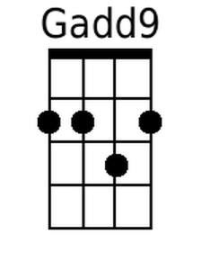
 | 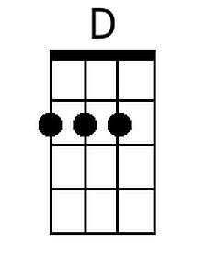
 | 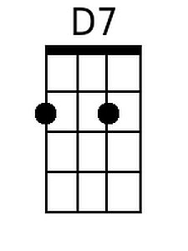
 | 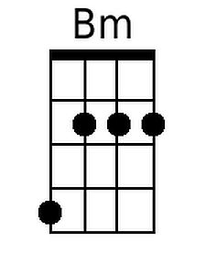
The Boxer (Paul Simon, 1968) (G)

Intro: Gadd9 | Gadd9 | G | G |  G D Em  I am just a poor boy, though my story's seldom told.  D D7  I have squandered my resistance, for a pocket full of mumbles,  G D Em  Such are promises. All lies and jests,  D C G | D | D | D | G | G | G  Still a man hears what he wants to hear, and disregards the rest.  G D Em  When I left my home and my family, I was no more than a boy  D D7  In the company of strangers, in the quiet of the railway station.  G Em D C  Running scared. Laying low, seeking out the poorer quarters  G D C Bm Am G  Where the ragged people go, looking for the places only they would know.  Chorus  Em Bm  Lie-la-lie, Lie-la-lie, la lie-la-lie,  Em D G | G | G  Lie-la-lie, Lie-la-lie, la la la la lie.  G D Em  Asking only workman's wages, I come looking for a job,  D D7 G  But I get no offers. Just a come-on from the whores on Seventh Avenue.  D Em D C  I do de-clare there were times when I was so lonesome  G D | G | G | G  I took some comfort there. Ooo-la-la, la-la la la.  (Instrumental Verse) (Chorus)  G D Em D  Then I'm laying out my winter clothes and wishing I was gone, going home.  D G Bm Em D  Where the New York City winters are-n't bleeding me, Leading me, going home.  | D7 | D7 | G | G | G |  G D Em  In the clearing stands a boxer and a fighter by his trade  D D7  And he carries the reminders of every glove that laid him down  G D Em  Or cut him 'til he cried out iIn his anger and his shame  D C G | G G D G | D | C | G  "I am leaving, I am leaving" - but the fighter still re-mains.  Chorus (Repeat 8 times) | Baritone
 | 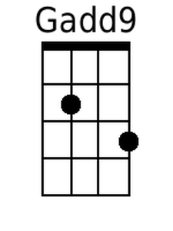
 | 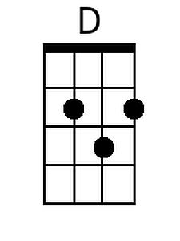
 | 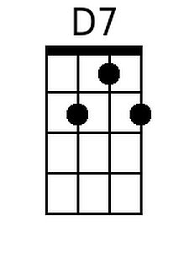
 | 