

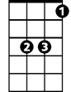

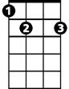
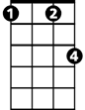


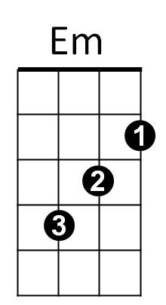


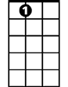
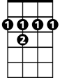
The Christmas Song (Mel Torme and Robert Wells) Key C
G
Gm
Eb
F
E7
Fm
C7
Am
Dm
C
A7
B7

C Dm Em Am
Chestnuts roasting on an open fire
C C7 F E7
Jack Frost nipping at your nose
Am Fm C B7
Yuletide carols being sung by a choir
Em A7 Dm G
And folks dressed up like Eskimos

C Dm Em Am
Everybody knows a turkey and some mistletoe
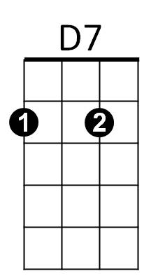

C C7 F E7
G7
Help to make the season bright
Am Fm C B7
Tiny tots with their eyes all aglow
Em Am F G7 C
Will find it hard to sleep to- night


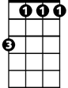
Bridge:
F
E7
Fm
Am
Em
Dm
C
BARITONE

Gm C Gm C
They know that San-ta's on his way
Gm C F
He’s loaded lots of toys and goodies in his sleigh
Fm Eb
And every mother’s child is gonna spy
Am D7 F G7
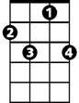
To see if Reindeer really know how to fly
C7

C Dm Em Am
And so I’m offering this simple phrase
C C7 F E7
To kids from one to ninety-two
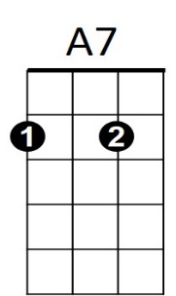
Am Fm C B7
B7
G
G7
Although it’s been said many times many ways -
F C G7 C
Merry Christmas to you

Repeat from Bridge
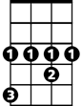
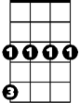
D7
Eb
Gm
Am Fm C B7
Although it’s been said many times many ways
F C F C
Merry Christmas, Merry Christmas,
F C G7 C
Merry Christmas - to - you

