
The Dock of the Bay (Otis Redding & Steve Cropper, 1967) (G)
(Sittin' On) The Dock of the Bay by Otis Redding (1967)
Lyrics Source: (Sittin’ On) The Dock of the Bay (The Estate of Otis Redding)

Intro (4 measures) G  G B7  Sittin’ in the morning sun  C B Bb A  I’ll be sittin’ when the even-ing comes  G B7  Watching the ships roll in  C B Bb A  Then I watch them roll a-way a - gain, yeah  G E7  I’m sittin’ on the dock of the bay  G E7  Watchin’ the tide roll a-way, ooh  G A  I’m just sittin’ on the dock of the bay  G E7  Wastin’ time  G B7  I left my home in Georgia  C B Bb A  Headed for the Fris-co Bay  G B7  Cuz I’ve had nothing to live for  C B Bb A  And look like nothing’s gonna come my way  G E7  So, I’m just gon’ sit on the dock of the bay  G E7  Watchin’ the tide roll a-way, ooh  G A  I’m sittin’ on the dock of the bay  G E7  Wastin’ time  Bridge  G D C  Looks like nothing’s gonna change  G D C  Every-thing still remains the same  G D C  I can’t do what ten people tell me to do  F D  So I guess I’ll re-main the same, listen | G B7  Sittin’ here resting my bones  C B Bb A  And this loneliness won’t leave me a - lone,  listen  G B7  Two thousand miles I roam  C B Bb A  Just to make this dock my home, now  G E7  I’m just gon’ sit at the dock of a bay  G E7  Watchin’ the tide roll a-way, ooh  G A  Sittin’ on the dock of the bay  G E7  Wastin’ time  Outro [Whistle and soften]  G | E7 | G | E7 | (2x) End on C
 | 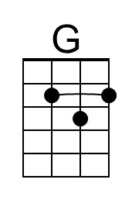 | 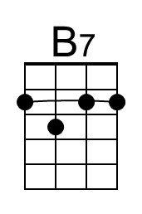 | 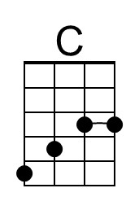 | 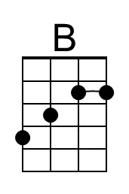 | 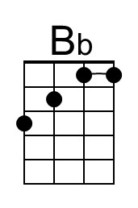
 | 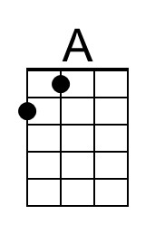 | 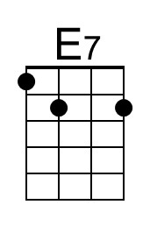 | 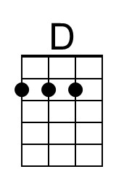 | 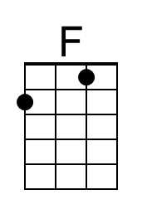 | 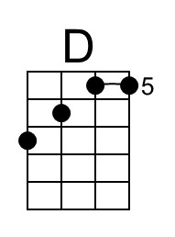
 | 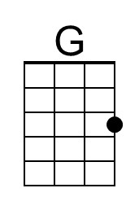 | 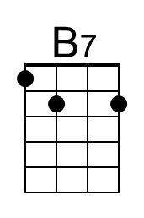 | 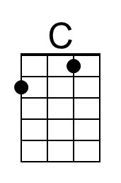 | 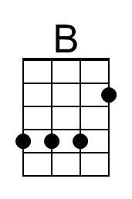 | 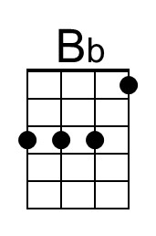
 | 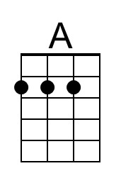 | 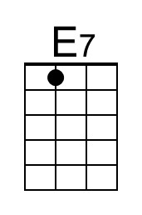 | 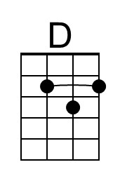 | 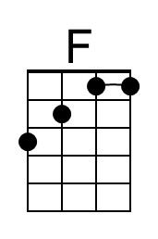

The Dock of the Bay (Otis Redding & Steve Cropper, 1967) (C)
(Sittin' On) The Dock of the Bay by Otis Redding (1967)
Lyrics Source: (Sittin’ On) The Dock of the Bay (The Estate of Otis Redding)

Intro (4 measures) C  C E7  Sittin’ in the morning sun  F E Eb D  I’ll be sittin’ when the even-ing comes  C E7  Watching the ships roll in  F E Eb D  Then I watch them roll a-way a - gain, yeah  C A7  I’m sittin’ on the dock of the bay  C A7  Watchin’ the tide roll a-way, ooh  C D  I’m just sittin’ on the dock of the bay  C A7  Wastin’ time  C E7  I left my home in Georgia  F E Eb D  Headed for the Fris-co Bay  C E7  Cuz I’ve had nothing to live for  F E Eb D  And look like nothing’s gonna come my way  C A7  So, I’m just gon’ sit on the dock of the bay  C A7  Watchin’ the tide roll a-way, ooh  C D  I’m sittin’ on the dock of the bay  C A7  Wastin’ time  Bridge  C G F  Looks like nothing’s gonna change  C G F  Every-thing still remains the same  C G F  I can’t do what ten people tell me to do  Gb G  So I guess I’ll re-main the same, listen | C E7  Sittin’ here resting my bones  F E Eb D  And this loneliness won’t leave me a - lone,  listen  C E7  Two thousand miles I roam  F E Eb D  Just to make this dock my home, now  C A7  I’m just gon’ sit at the dock of a bay  C A7  Watchin’ the tide roll a-way, ooh  C D  Sittin’ on the dock of the bay  C A7  Wastin’ time  Outro [Whistle and soften]  C | A7 | C | A7 | (2x) End on F
 |  |  |  | 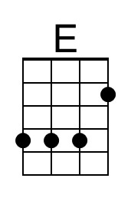 | 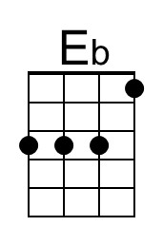
 |  | 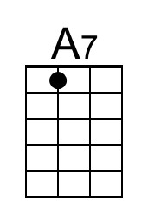 |  | 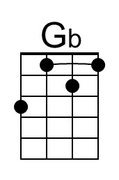
 |  |  |  | 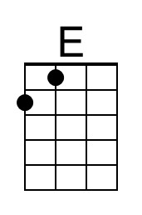 | 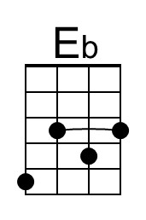
 |  | 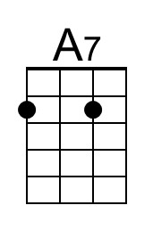 | 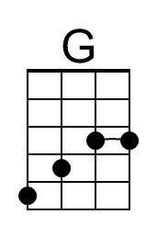 | 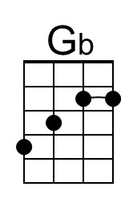

The Dock of the Bay (Otis Redding & Steve Cropper, 1967) (D)
(Sittin' On) The Dock of the Bay by Otis Redding (1967)
Lyrics Source: (Sittin’ On) The Dock of the Bay (The Estate of Otis Redding)

Intro (4 measures) D  D F#7  Sittin’ in the morning sun  G F# F E  I’ll be sittin’ when the even-ing comes  D F#7  Watching the ships roll in  G F# F E  Then I watch them roll a-way a - gain, yeah  D B7  I’m sittin’ on the dock of the bay  D B7  Watchin’ the tide roll a-way, ooh  D E  I’m just sittin’ on the dock of the bay  D B7  Wastin’ time  D F#7  I left my home in Georgia  G F# F E  Headed for the Fris-co Bay  D F#7  Cuz I’ve had nothing to live for  G F# F E  And look like nothing’s gonna come my way  D B7  So, I’m just gon’ sit on the dock of the bay  D B7  Watchin’ the tide roll a-way, ooh  D E  I’m sittin’ on the dock of the bay  D B7  Wastin’ time  Bridge  D A G  Looks like nothing’s gonna change  D A G  Every-thing still remains the same  D A G  I can’t do what ten people tell me to do  C A  So I guess I’ll re-main the same, listen | D F#7  Sittin’ here resting my bones  G F# F E  And this loneliness won’t leave me a - lone,  listen  D F#7  Two thousand miles I roam  G F# F E  Just to make this dock my home, now  D B7  I’m just gon’ sit at the dock of a bay  D B7  Watchin’ the tide roll a-way, ooh  D E  Sittin’ on the dock of the bay  D B7  Wastin’ time  Outro [Whistle and soften]  D | B7 | D | B7 | (2x) End on G
 |  | 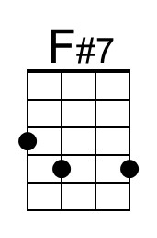 |  | 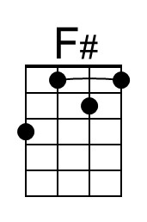
 |  |  |  | 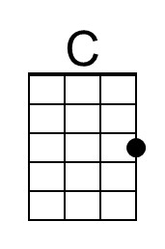
 |  | 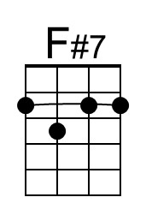 |  | 