Dock of the Bay (Otis Redding)

G B7
Sittin' in the morning sun
C B Bb A
I'll be sittin' in the eve-n- ing come
G B7
Watching the ships roll in,
C B Bb A
Then I watch them roll a-wa-ay a - gain, yeah

CHORUS:
G E7
I'm sittin' on the dock of the bay
G E7
Watching the tide roll away
G A
Ooh I'm just sittin' on the dock of the bay
G E7

Wasti ng ti---ime
G

G B7
I left my home in Georgia
C B Bb A
Headed for the Fris-co bay
G B7

'Cause I've had nothing to live for
Bb
C B Bb A
And look like nothing's gonna co-me my way

(CHORUS)

G D C
Look like nothing's gonna change
G D C
Everything still remains the same
G D C
I can't do what ten people tell me to do
F D
So I guess I'll remain the same
BARITONE

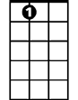


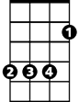
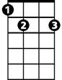
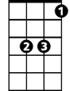
A
E7
D
F
G
C
B
B7
Bb

G B7
Sittin' here resting my bones
C B Bb A
And this loneliness won't leave me a - lone
G B7
These two thousand miles I roamed
C B Bb A
Just to make this do-ck my home
G E7
Now I'm just gonna sit at the dock of the bay
G E7
Watching the tide roll away, oooh
G A
Sittin' on the dock of the bay
G E7
Wasting ti---ime

OUTRO: whistle and fade out (kazoos?)
G E7 / G E7
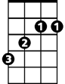
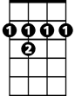
B
C
B7

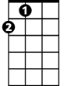
D
E7
A

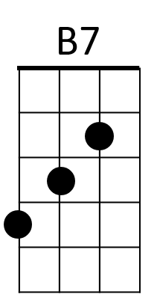
F

