



The Ella B (Russell Smith, 1975) (C)
The Ella B by The Amazing Rhythm Aces

C  Have you ever took a boat ride  G7  Down the Mississippi  Well if you ever do you oughta take it on the  C  Ella B  G7  Cause she starts off in St. Louis in Missouri  And she takes you down to New Orleans and  C  On out to the sea  F C  Well you heard about the good Queen Mary  F C  That sailed on the seven seas  F C  But you ain't never took no boat ride,  G7 C  Till' you been riding on the Ella B  C G7  Her accommodations are among the best  Give you three square meals a day  C  And a place to rest  You just smell them ol’ hot biscuits  G7  And the country ham  Good ‘ol fried chicken, mashed potatoes  C  And candied yams  F C  Well you heard about the Constitution ~  F C  Fightin’n th’ Revolutionary War |  |  |  |  | F C  For America’s inland Navy  G7 C  She’s the finest from shore to shore  BRIDGE: Chords for verse  C  It takes about a week ~  G7  To get back down that ol’ river  Once you get on board you just wish  C  It would last forever  Oh you just sit out on the deck,  G7  Fish off the side all day  Watch the sunny southland roll by  C  And dream your blues away  F C  Well you heard about the ship Titanic ~  F C  Sailing on the northern sea  F C  But you ain't never took no boat ride,  G7 C  Till' you been riding on the Ella B  (Ending)  C  Well there ain't no tourist class ~  G7  And it ain't too fast  C  Just one for all and we' re having a blast
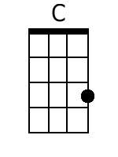 | 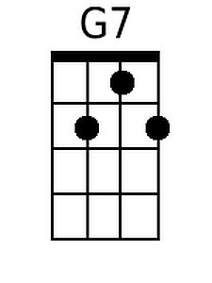 | 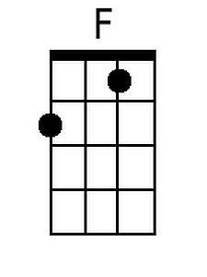 |  |  |  | Bari | 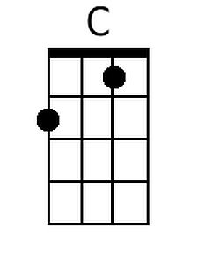 | 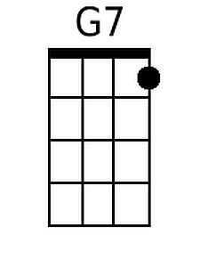 | 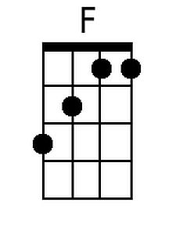

The Ella B (Russell Smith, 1975) (G)
The Ella B by The Amazing Rhythm Aces

G  Have you ever took a boat ride  D7  Down the Mississippi  Well if you ever do you oughta take it on the  G  Ella B  D7  Cause she starts off in St. Louis in Missouri  And she takes you down to New Orleans and  G  On out to the sea  C G  Well you heard about the good Queen Mary  C G  That sailed on the seven seas  C G  But you ain't never took no boat ride,  D7 G  Till' you been riding on the Ella B  G D7  Her accommodations are among the best  Give you three square meals a day  G  And a place to rest  You just smell them ol' hot biscuits  D7  And the country ham  Good 'ol fried chicken, mashed potatoes  G  And candied yams  C G  Well you heard about the Constitution ~  C G  Fightin'n th' Revolutionary War |  |  |  |  | C G  For America's inland Navy  D7 G  She's the finest from shore to shore  BRIDGE: Chords for verse  G  It takes about a week ~  D7  To get back down that ol' river  Once you get on board you just wish  G  It would last forever  Oh you just sit out on the deck,  D7  Fish off the side all day  Watch the sunny southland roll by  G  And dream your blues away  C G  Well you heard about the ship Titanic ~  C G  Sailing on the northern sea  C G  But you ain't never took no boat ride,  D7 G  Till' you been riding on the Ella B  (Ending)  G  Well there ain't no tourist class ~  D7  And it ain't too fast  G  Just one for all and we' re having a blast
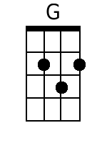 | 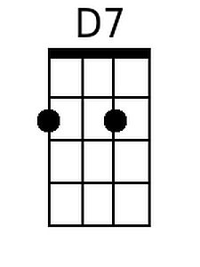 |  |  |  |  | Bari | 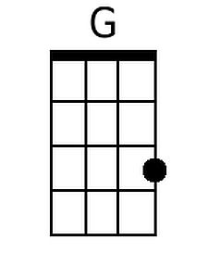 | 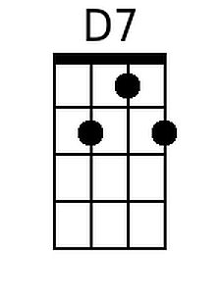

The Ella B (Russell Smith, 1975) (NN)
The Ella B by The Amazing Rhythm Aces

1  Have you ever took a boat ride  5(7)  Down the Mississippi  Well if you ever do you oughta take it on the  1  Ella B  5(7)  Cause she starts off in St. Louis in Missouri  And she takes you down to New Orleans and  1  On out to the sea  4 1  Well you heard about the good Queen Mary  4 1  That sailed on the seven seas  4 1  But you ain't never took no boat ride,  5(7) 1  Till' you been riding on the Ella B  1 5(7)  Her accommodations are among the best  Give you three square meals a day  1  And a place to rest  You just smell them ol' hot biscuits  5(7)  And the country ham  Good 'ol fried chicken, mashed potatoes  1  And candied yams  4 1  Well you heard about the Constitution ~  4 1  Fightin'n th' Revolutionary War  4 1  For America's inland Navy  5(7) 1  She's the finest from shore to shore  BRIDGE: Chords for verse |  | 1 | 5(7) | 4
 |  | A | E7 | D
 |  | C | G7 | F
 |  | D | A7 | G
 |  | F | C7 | Bb
 |  | G | D7 | C
1
It takes about a week ~
5(7)
To get back down that ol' river
Once you get on board you just wish
1
It would last forever
Oh you just sit out on the deck,
5(7)
Fish off the side all day
Watch the sunny southland roll by
1
And dream your blues away
4 1
Well you heard about the ship Titanic ~
4 1
Sailing on the northern sea
4 1
But you ain't never took no boat ride,
5(7) 1
Till' you been riding on the Ella B

(Ending)
1
Well there ain't no tourist class ~
5(7)
And it ain't too fast
1
Just one for all and we' re having a blast

