The Fishin’ Hole
(Earle Hagen, Herbert W. Spencer, and Everett Sloane, 1960)
Theme Song from The Andy Griffith Show – Version 1 (Theresa Miller)

Riff 1: leads in to F chord
A --------------------
E -----------0—1---
C ---0—2-----------
G --------------------

Intro: *** (line 4 instrumental)

C Am C D7 G7
Well now, take down your fishing pole and meet me at the fishing hole
C Am C D G7
We may not get a bite all day but don't you rush away ^
C Am C D7 G7
What a great place to rest your bones and mighty fine for skipping stones
*** C Am C G7 C
You'll feel fresh as a lemonade a-setting in the shade

(Riff) F C (Riff) F C
Whether it's hot, whether it's cool
(Riff) F C D7 G7
Oh what a spot for whistling like a fool

C Am C D7 G7
What a fine day to take a stroll and wind up at the fishing hole
C Am C G7 C
I can't think of a better way to pass the time of day

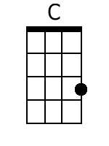 | 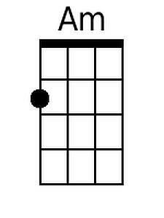 | 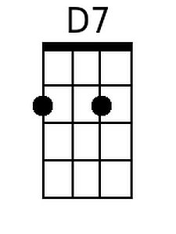 | 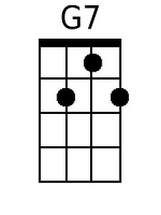 | 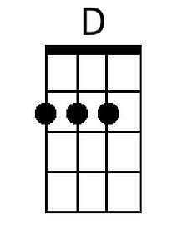 | 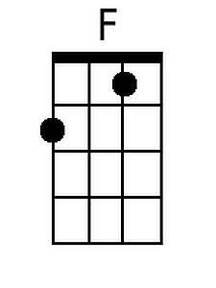
Bari
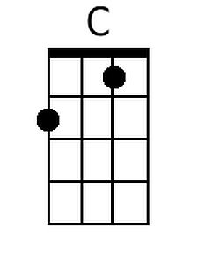 | 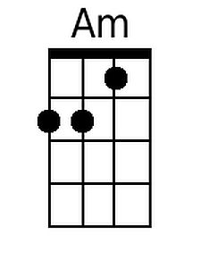 | 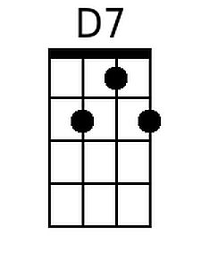 | 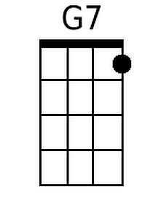 | 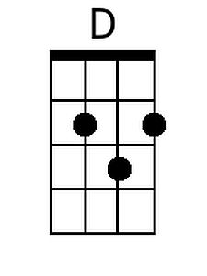 | 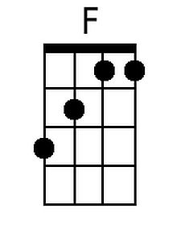

The Fishin’ Hole (Version 1), p. 2

Verse melody (whistle, or kazoo, and play chords only)

C Am / C D7 - G7 / C Am / C D G7 ^

C Am / C D7 - G7 / C Am / C G7 C

(Riff) F C / (Riff) F C / (Riff) F C / D7 G7

C Am C D7 G7
We'll have no need to call the roll when we get to the fishing hole
C Am C D G7
They'll be you, me, and old dog, Trey, to do the time away ^

C Am C D7 G7
If we don't hook a perch or bass we'll cool our toes in dewy grass
C Am C G7 C
Or else pull up a weed to chaw and maybe sit and jaw

(Riff) F C (Riff) F C (Riff)
Hanging around, taking our ease
F C D7 G7
Watching that hound a scratching at his fleas

(Sing acapella with snaps)
X X X X X X X
I'm gonna take down my fish-in’ pole and meet you at the fish-in hole
X X X X X X X C (single strum)
I can't think of a bet-ter way to pass the time of day

The Fishin’ Hole
(Earle Hagen, Herbert W. Spencer, and Everett Sloane, 1960)
Theme Song from The Andy Griffith Show – Version 2 (Theresa Miller)

Riff 1: leads in to F chord  A --------------------  E -----------0—1---  C ---0—2-----------  G -------------------- | Riff 2  A-----------------------------------------  E-----3—3 --- 1---0------------------  C-------------------------0--------------

Intro: *** (line 4 instrumental)

C Am C D7 G7
Well now, take down your fishing pole and meet me at the fishing hole
C Am C D G7
We may not get a bite all day but don't you rush away ^
C Am C D7 G7
What a great place to rest your bones and mighty fine for skipping stones
*** C Am C G7 C
You'll feel fresh as a lemonade a-setting in the shade

(Riff) F C (Riff) F C
Whether it's hot, whether it's cool
(Riff) F C D7 G7 or (Riff 2)
Oh what a spot for whistling like a fool

C Am C D7 G7
What a fine day to take a stroll and wind up at the fishing hole
C Am C G7 C
I can't think of a better way to pass the time of day

Bari
The Fishin’ Hole (Version 2), p. 2

Verse melody (whistle, or kazoo, and play chords only)

C Am / C D7 - G7 / C Am / C D G7 ^

C Am / C D7 - G7 / C Am / C G7 C

(Riff) F C / (Riff) F C / (Riff) F C / D7 G7 (Riff 2)

C Am C D7 G7
We'll have no need to call the roll when we get to the fishing hole
C Am C D G7
They'll be you, me, and old dog, Trey, to do the time away ^

C Am C D7 G7
If we don't hook a perch or bass we'll cool our toes in dewy grass
C Am C G7 C
Or else pull up a weed to chaw and maybe sit and jaw

(Riff) F C (Riff) F C
Whether it's hot, whether it's cool
(Riff) F C D7 G7 or (Riff 2)
Oh what a spot for whistling like a fool

Riff 2 A-----------------------------------------
E-----3—3 --- 1---0------------------
C-------------------------0--------------

(Sing acapella with snaps)
X X X X X X X
I'm gonna take down my fish-in’ pole and meet you at the fish-in hole

X X X X X X X C (single strum)
I can't think of a bet-ter way to pass the time of day

