The Impossible Dream (Joe Darion / Mitchell Leigh) Key C

C Cmaj7
To dream - the impossible dream
F Dm
To fight the unbeatable foe
Em F
To bear with unbearable sorrow
Dm G
To run where the brave dare not go

C Cmaj7
To right the un-rightable wrong
F Dm
To love pure and chaste from afar
Em F
To try when your arms are too weary
Dm G
To reach the unreachable star

Chorus:
C Am
This is my quest, to follow that star
Em F
No matter how hopeless, no matter how far
Am
To fight for the right –
F
Without question or pause
C Am
To be willing to march into Hell
F Bb
For a heavenly cause
Dm Bb
And I know if I'll only be true –
Em
To this glorious quest
F Dm
That my heart will lay peaceful and calm
E7 G G7
When I'm laid to my rest
BARITONE

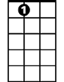



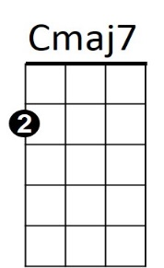



G7
E7
Am
F
Dm
Em
G
C

C Cmaj7
And the world will be better for this
F
That one man,
Dm
Scorned and covered with scars
Em F
Still strove with his last ounce of courage
Dm G
To reach the unreachable star

(Chorus)

C Cmaj7
And the world will be better for this
F
That one man,
Dm
Scorned and covered with scars
Em F
Still strove with his last ounce of courage
C Em C
To reach the unreachable star
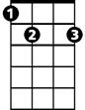
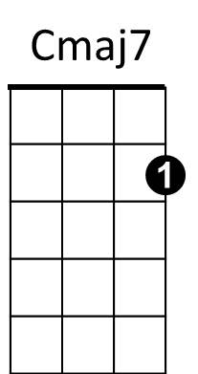
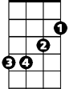

Am
Bb
E7
Em
F
G
C
Dm


G7

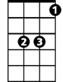
Bb

The Impossible Dream (Joe Darion / Mitchell Leigh) Key G
G Gmaj7
To dream - the impossible dream
C Am
To fight the unbeatable foe
Bm C
To bear with unbearable sorrow
Am D
To run where the brave dare not go

G Gmaj7
To right the un-rightable wrong
C Am
To love pure and chaste from afar
Bm C
To try when your arms are too weary
Am D
To reach the unreachable star

Chorus:
G Em
This is my quest, to follow that star
Bm C
No matter how hopeless, no matter how far
Em
G
To fight for the right –
C
Without question or pause
G Em
To be willing to march into Hell
Em
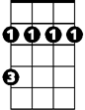
C F
Bm
For a heavenly cause
Am F
And I know if I'll only be true –
Bm
To this glorious quest
C Am
That my heart will lay peaceful and calm
B7 D D7
When I'm laid to my rest
BARITONE
F
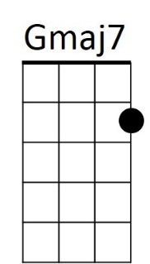
D
B7
Em
Bm
G
Am
C

G Gmaj7
And the world will be better for this
C
That one man,
Am
Scorned and covered with scars
Bm C
Still strove with his last ounce of courage
Am D
To reach the unreachable star

(Chorus)

G Gmaj7
And the world will be better for this
C
That one man,
Am
Scorned and covered with scars
Bm C
Still strove with his last ounce of courage
G Bm G
To reach the unreachable star

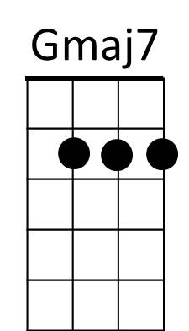
D
Am
C

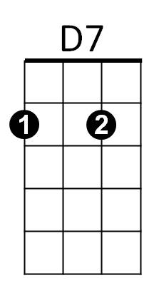
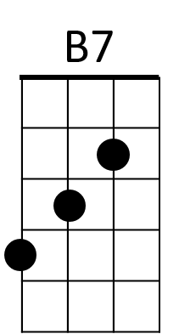
F
D7

