The Little Old Lady From Pasedena (Gary L Usher / Roger Christian) Key C

Intro: Eb G
It's the little old lady from Pasadena

C
The little old lady from Pasadena
F C
(Go granny, go granny, go granny, go!)
C
Has a pretty little flower bed of white gardenias
G D7 G
(Go granny, go granny, go granny, go!)
C Am F
But parked in a rickety old garage
Dm Bb G
Is a brand new, shiny red, super-stock Dodge!

Chorus:
C
An d everybody's saying that there's nobody meaner
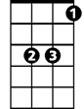
Eb
Than the little old lady from Pasadena
F
She drives real fast and she drives real hard
C
She's the terror of Colorado Boulevard
Eb G
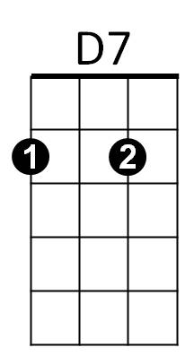
It's the little old lady from Pasadena

C
If you see her on the street, don't try to choose her
F C
(Go granny, go granny, go granny, go!)
C
You might drive a goer but you'll never lose her
G D7 G
(Go granny, go granny, go granny, go!)
C Am F
She's gonna get a ticket now, sooner or later
Dm Bb G
'Cause she can't keep her foot off the accelerator!
BARITONE



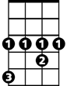



(Chorus)
Dm
C
G
Eb
Am
D7
F

C
The little old lady from Pasadena
F C
(Go granny, go granny, go granny, go!)
C
Has a pretty little flower bed of white gardenias
G D7 G
(Go granny, go granny, go granny, go!)
C Am F
The guys come to race her from miles around
Dm Bb G
But she'll give 'em a length, then she'll shut 'em down

(Chorus)

2x C F C
Go granny, go granny, go granny, go!
G D7 G
Go granny, go granny, go granny, go!

F
C
G


Bb
Dm
Am

Bb

. The Little Old Lady From Pasedena (Gary L Usher / Roger Christian)

Bb D
It's the little old lady from Pasadena

G
The little old lady from Pasadena
C G
(Go granny, go granny, go granny, go!)
G
Has a pretty little flower bed of white gardenias
D A7 D
(Go granny, go granny, go granny, go!)
G Em C
But parked in a rickety old garage
Am F D
Is a brand new, shiny red, super-stock Dodge!

Chorus:
G
And everybody's saying that there's nobody meaner

Than the little old lady from Pasadena
C
She drives real fast and she drives real hard
G
She's the terror of Colorado Boulevard
Bb D
It's the little old lady from Pasadena
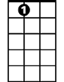
A7
G
If you see her on the street, don't try to choose her
C G
(Go granny, go granny, go granny, go!)
G
You might drive a goer but you'll never lose her
D A7 D
(Go granny, go granny, go granny, go!)
G Em C
She's gonna get a ticket now, sooner or later
Am F D
'Cause she can't keep her foot off the accelerator!
F
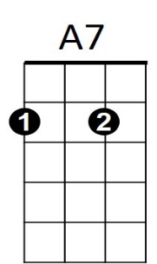
Am
Em
BARITONE
D
G
Bb
(Chorus)
C

G
The little old lady from Pasadena
C G
(Go granny, go granny, go granny, go!)
G
Has a pretty little flower bed of white gardenias
D A7 D
(Go granny, go granny, go granny, go!)
G Em C
The guys come to race her from miles around
Am F D
But she'll give 'em a length, then she'll shut 'em down

(Chorus)

2x G C G
Go granny, go granny, go granny, go!
D A7 D
Go granny, go granny, go granny, go!
. . .
.
G
Bb

C
D

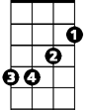
Em
F
Am

