The Muppet Show Theme (Sam Pottle / Jim Henson)

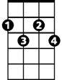
C
Ebdim
C Ebdim G7
It's time to play the music
C Ebdim G7
It's time to light the lights
C F Fm Am Abaug G


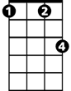
It's time to meet the Muppets on the Muppet Show tonight
G7
F
Fm

C Ebdim G7
It's time to put on make up
C Ebdim G7
It's time to dress up right
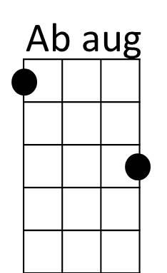

C F Fm Am Abaug G
Am
It's time to raise the curtain on the Muppet Show tonight

C Ebdim G7
It's time to play the music
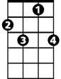
C Ebdim G7
F7
It's time to light the lights
C F Fm C F Fm
It's time to get things started (Why don’t you get things started?)
C

on the most sensational,
Dm
Am F F7
Inspirational celebrational muppetstational
Dm F G7 C
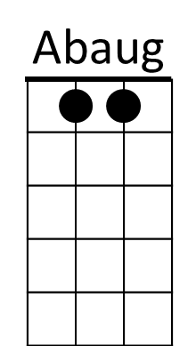

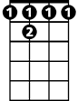
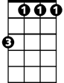


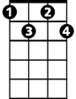
This is what we call the Muppet Show
BARITONE
Dm
F 7
Am
Fm
F
G7
Ebdim
C

