The Music of the Night (Andrew Lloyd Webber / Charles Hart / Richard Stilgoe)
(GCEA) Key F

F C F C
Night time sharpens, heightens each sensation
F C Bb C
Darkness stirs and wakes imagination
Bb F Bb F
Silently the senses abandon their defenses
Bb Eb Bb F / Gm Am
F C F C
Slowly, gently night unfurls it's splendor
F C Bb C
Grasp it, sense it, tremulous and tender
Bb F Bb F
Turn your face away from the garish light of day
Bb Eb Bb F
Turn your thoughts away from cold, unfeeling light
Bb C7 F
And listen to the music of the night

Eb
Close your eyes and surrender
Ab
To your darkest dreams
Db G G7
Purge your thoughts of the life you knew before
C C7 F
Close your eyes, let your spirit start to soar
Am E7 A7
And you’ll live as you never lived before

F C F C
Softly, deftly, music shall caress you
F C Bb C
Hear it, feel it, secretly possess you
Bb F Bb F
Open up your mind, let your fantasies unwind
Bb Eb Bb F
In this darkness which you know you cannot fight
Bb C7 F
The darkness of the music of the night

Eb Ab
Let your mind start a journey to a strange new world
Db G G7
Leave all thoughts of the life you knew before
C C7 F
Let your soul take you where you long to be
Am E7 A7
Only then can you belong to me

F C F C
Floating, falling, sweet intoxication
F C Bb C
Touch me, trust me, savor each sensation
Bb F Bb F
Let the dream begin, let your darker side give in
Bb Eb Bb F
To the power of the music that I write
Bb C7 F
The power of the music of the night
F C F C / F C Bb C / Bb F Bb F
Bb Eb Bb F
You alone can make my song take flight
Bb C7 Bb Gm F#m Bb
Help me make the music of the night
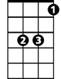



Eb
Bb
C
F

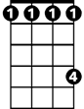
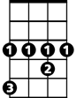


Db
Ab
Am
Gm

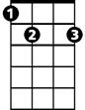



E7
C7
G7
G

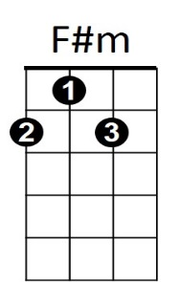
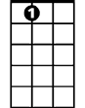
A7

The Music of the Night (Andrew Lloyd Webber / Charles Hart / Richard Stilgoe)
BARITONE (DGBE) Key F

F C F C
Night time sharpens, heightens each sensation
F C Bb C
Darkness stirs and wakes imagination
Bb F Bb F
Silently the senses abandon their defenses
Bb Eb Bb F / Gm Am
F C F C
Slowly, gently night unfurls it's splendor
F C Bb C
Grasp it, sense it, tremulous and tender
Bb F Bb F
Turn your face away from the garish light of day
Bb Eb Bb F
Turn your thoughts away from cold, unfeeling light
Bb C7 F
And listen to the music of the night
BARITONE
Eb
Close your eyes and surrender
Ab
To your darkest dreams
Db G G7
Purge y our thoughts of the life you knew before
C C7 F
Close your eyes, let your spirit start to soar
Am E7 A7
And you’ll live as you never lived before

F C F C
Softly, deftly, music shall caress you
F C Bb C
Hear it, feel it, secretly possess you
Bb F Bb F
Open up your mind, let your fantasies unwind
Bb Eb Bb F
In this darkness which you know you cannot fight
Bb C7 F
The darkness of the music of the night

Eb Ab
Let your mind start a journey to a strange new world
Db G G7
Leave all thoughts of the life you knew before
C C7 F
Let your soul take you where you long to be
Am E7 A7
Only then can you belong to me

F C F C
Floating, falling, sweet intoxication
F C Bb C
Touch me, trust me, savor each sensation
Bb F Bb F
Let the dream begin, let your darker side give in
Bb Eb Bb F
To the power of the music that I write
Bb C7 F
The power of the music of the night
F C F C / F C Bb C / Bb F Bb F
Bb Eb Bb F
You alone can make my song take flight
Bb C7 Bb Gm F#m Bb
Help me make the music of the night

Eb
Bb
F
C

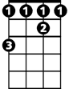
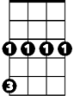
Db
Gm
Ab
Am

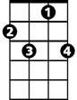
C7
G7
G
E7

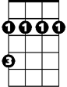
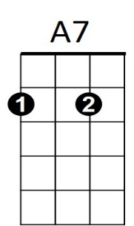
F#m

